Multi-Camera Fall Detection System on
Edge Device with VLM Verification

Hoàng Anh Dũng (Team leader); Nguyễn Quang Khánh; Nguyễn Tấn Dũng
Advisor: Bùi Văn Hiệu

ACKNOWLEDGE
We would like to express our deepest gratitude to our mentor, Mr. Bui Van Hieu, for his invaluable guidance, patience, and continuous support throughout the development of this project. His professional expertise and encouragement not only helped us navigate numerous challenges during the implementation process but also inspired us to adopt a more rigorous and critical approach to our work.
We would also like to extend our sincere appreciation to the Department of Information Technology at FPT University for providing the necessary facilities, resources, and academic environment that made this project possible.
Equally important to us is the unwavering support of our families, who have stood by us throughout this journey—offering steadfast encouragement during times of uncertainty and hardship. Their patience, motivation, and belief in us provided the strength to bring this project to completion.
Finally, we are genuinely grateful to everyone, whether explicitly mentioned or not, who contributed to the success of this capstone project.

ABSTRACT
Falls are the leading cause of injury and mortality among elderly individuals living alone, with an estimated 684,000 fatal falls occurring globally each year and 28–42% of adults aged 65+ falling at least once annually [1]. Automatic fall detection via surveillance cameras is thus of high practical value. Although the field has reached research maturity—433 computer-vision fall-detection studies were surveyed through 2025 [2]—most existing systems rely on a single camera, which inherently suffers from blind spots and occlusion. Multi-camera setups mitigate occlusion but introduce three technical challenges that remain unresolved on resource-constrained edge hardware: (Re-Identification) loss of consistent identity as a person moves across non-overlapping camera views; (Identity Association) redundant identity assignment when two cameras concurrently observe the same subject in an overlapping zone; and (Boundary Feature Fusion) missed fall detections caused by partial occlusion at camera boundaries.
This project proposes an edge–cloud architecture on an NVIDIA Jetson Nano. Identity Association is resolved via a training-free homography projection that matches identities on a real-world floor plane. Boundary Feature Fusion is addressed by a Cross-Camera Attention module within a shared Secondary Inference Engine (SGIE)—a YOLOv8n-cls backbone with Efficient Multi-Scale Attention (EMA), trained with Focal Loss—which fuses multi-view features weighted by detection confidence. Re-Identification is handled by a dedicated Re-ID branch in the SGIE (a 256-dim embedding trained with Triplet Loss). All candidate fall events are further verified by a Vision-Language Model (VLM) before alerting, to suppress false alarms. Three existing baselines (PIFR and two open-source systems) were reimplemented for multi-camera deployment and benchmarked on our custom PFDD-Test dataset under identical Jetson hardware conditions.

[Kết quả: bổ sung sau khi hoàn tất thực nghiệm Tuần 6–7 — Accuracy/Precision/Recall/F1 theo từng lớp và FPS thực tế trên thiết bị.] Từ khóa: phát hiện ngã đa camera, đối chiếu định danh xuyên camera, che khuất đa góc nhìn, điện toán biên, tái định danh dựa trên homography, xác minh bằng VLM.

1. INTRODUCTION
Global population aging is driving increasing demand for in-home safety monitoring for elderly individuals who live alone or with limited family care. Falls are among the most serious health risks for this group: an estimated 28–35% of adults aged 65+ and 32–42% of those over 70 fall at least once annually, with roughly 684,000 fall-related deaths occurring globally each year, over 80% in low- and middle-income countries [1]. Global Burden of Disease data further show a 182% rise in fall incidence among adults 65+ since 1990 [3], indicating a growing rather than stabilizing burden. In Vietnam, an estimated 1.5–1.9 million elderly people fall annually, with about 5% requiring hospitalization [4]—a significant figure given limited in-home care and remote monitoring infrastructure. Beyond immediate injury, an undetected fall (a "long-lie") sharply raises the risk of secondary complications such as aspiration pneumonia, dehydration, and pressure injuries, even without severe initial trauma.
Vision-based fall detection has consequently become a mature research area: a 2026 systematic mapping study synthesized 433 video-based fall detection studies through 2025, spanning Feature Engineering, Deep Learning, and Hybrid approaches [2]. Such systems are non-invasive and require no wearable device, fitting naturally into elderly routines. Most existing frameworks operate on a single camera, using pose or motion features to classify fall states, and many achieve strong accuracy on public benchmarks. However, single-camera systems share an unresolved limitation: occlusion and blind spots. When a person moves behind furniture or is partially blocked from view, the system loses the visual context needed for reliable classification, causing missed falls or false alarms on ordinary activities such as sitting or bending.
Multi-camera deployment is a natural remedy for occlusion, but it is not simply a matter of duplicating single-camera pipelines. Fusing multi-view observations of the same person — across overlapping or non-overlapping fields of view — introduces re-identification and multi-target association problems absent from single-camera systems. Current multi-camera fall detection research, which largely focuses on pose classification accuracy or backbone design, has yet to address this gap explicitly, particularly under real-time constraints on edge hardware such as the NVIDIA Jetson platform. Building on these limitations, this project formalizes three technical challenges in multi-camera fall detection for indoor environments — Re-Identification, Identity Association, and Boundary Feature Fusion — which Section 1.2 defines in detail and which anchor the remainder of this report.
Re-Identification— Re-Identification under Camera Handoff
This problem concerns maintaining correct individual identities when a person exits the field of view (FOV) of one camera and subsequently re-appears within the FOV of another, where no direct visual overlap exists between the two cameras for instantaneous matching. For example, when an elderly individual transitions from a hallway (monitored by Camera 1) into a living room (monitored by Camera 2), the system temporarily loses visual tracking during the transit through the blind zone. Upon re-emergence, the framework must accurately determine whether the subject is an existing or new identity. Existing Person Re-Identification (Re-ID) methods predominantly rely on appearance features learned from large-scale pedestrian datasets. Consequently, they require dedicated neural networks that impose non-trivial computational overhead, while their matching accuracy deteriorates under significant variations in lighting conditions and camera viewing angles typical of home environments. In practice, recent surveys on multi-camera tracking confirm that maintaining continuously tracked trajectories and consistent identity assignments across multi-camera networks remains an open research challenge [5].
Identity Association — Cross-Camera Identity Association under Overlapping FoV
When two cameras with overlapping FOVs observe the same individual simultaneously, each camera independently operates its own object tracker. Without cross-camera coordination, the system may assign two distinct tracking IDs to the same individual. This results in identity duplication, leading to overcounting or, more critically for fall detection, conflicting state estimates (e.g., Camera 1 reporting "standing" while Camera 2 reports "fallen") for a single physical event. For instance, if an individual sits in the center of a living room observed concurrently by both Camera 1 and Camera 2, an uncoordinated system registers 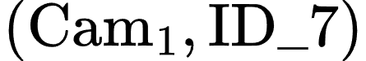 and 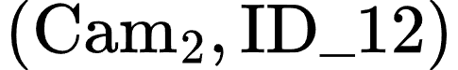 as separate entities. Research on identity assignment in overlapping camera networks confirms this as a persistent technical hurdle [6]. Certain contemporary multi-camera frameworks (such as DMMA proposed by Yang et al. [6]) deliberately avoid reliance on camera calibration to maintain flexibility for mobile cameras. However, this trade-off necessitates computing deep learning-based appearance embeddings for overlapping region matching—a task that could be executed at significantly lower computational cost using pure geometric transformation when dealing with fixed cameras, as in the smart-home surveillance setup of this project.
Boundary Feature Fusion — Multi-View Feature Fusion for Fall Classification
This scenario occurs when a fall event takes place directly at the boundary region between the FOVs of two cameras, resulting in each individual camera capturing only a partial view of the subject's body or experiencing local visual occlusion. Under such conditions, neither camera independently receives sufficient visual evidence to classify the posture as a fall with high confidence. For example, if a person falls adjacent to a dining table, their upper body may be obstructed by the tabletop in Camera 1, while Camera 2 captures the lower body but suffers head occlusion caused by surrounding chairs. If processed independently, neither single-camera pipeline yields a confidence score high enough to trigger an alarm. Partial occlusion has been shown to severely degrade the accuracy of computer vision-based fall detection models [7]. This issue was recognized early in multi-camera fall detection literature; a seminal work [8] mitigated occlusion by assuming that the fallen individual remains unobstructed in at least one camera view. That is, it selected the single "cleanest" viewpoint rather than fusing information across multiple partially occluded streams—an approach proven to fail when this optimistic assumption no longer holds [9]. Boundary Feature Fusion represents the most complex of the three challenges because it cannot be solved solely through identity matching like Re-Identification and Identity Association. Instead, it demands feature-level fusion within the model architecture when no individual camera maintains an unobstructed view—a key research gap largely unaddressed by existing multi-camera fall detection literature (which primarily focuses on multi-target tracking and identity re-identification, closely aligned with Re-Identification and Identity Association).

1.3. Contributions
To address the three technical challenges introduced above, this thesis makes the following contributions, each mapped directly to Re-Identification, Identity Association, and Boundary Feature Fusion:
Overall architecture. We propose an end-to-end edge–cloud architecture for multi-camera fall detection, in which a cloud-tier Vision-Language Model (VLM) verifies every candidate fall event to suppress false alarms before alerting the user — jointly resolving Identity Association and Boundary Feature Fusion within a single real-time pipeline deployed on an NVIDIA Jetson Nano (4GB).
Re-Identification. Re-identification is performed by a dedicated, lightweight OSNet-based embedding model [18] that runs independently from the shared Pose SGIE, rather than as a branch attached to the shared pose backbone as in an earlier design iteration. This choice is grounded in direct empirical evidence rather than architectural reasoning alone: four independent training configurations of the shared-backbone approach consistently yielded Rank-1 accuracy of only 3.5–4.9% on the MSMT17 benchmark, and on a practical gallery-matching test using the system's own resident data, failed to correctly match any genuine pair (similarity scores 0.35–0.45, well below the operating threshold). Under the identical test, the pretrained OSNet embedding — despite never having been trained on the project's data or domain — correctly matched all genuine pairs (similarity scores 0.80–0.82). This counter-intuitive outcome, where a domain-specific backbone underperforms a generic off-the-shelf one, is attributed to task-objective conflict: the shared backbone is trained for posture classification, an objective that explicitly rewards appearance invariance, directly opposing the appearance-discriminative representation re-identification requires. The resulting OSNet embedding is combined with a system-level gallery-matching mechanism that accumulates multiple frames per observation before querying the gallery, with the stored gallery embedding updated via an exponential moving average (EMA) rather than overwritten outright, allowing the reference representation of a resident to adapt gradually across sessions. A camera-conditional normalization layer, intended to reduce appearance bias between the two fixed cameras, is identified as a promising direction for further improving matching accuracy and is discussed as a proposed extension in Section 4.3, where full architectural details of the Re-ID model and the gallery-matching mechanism are also given.
Identity Association. Combines a one-time floor calibration via homography (requiring no model training) with the Hungarian algorithm (Kuhn, 1955) [29] to find a globally optimal pairing between observations from the two cameras, based on the distance between their bounding boxes after projection onto the real-world floor plane; pairs exceeding a fixed distance threshold — determined empirically from on-site measurements (Section 6.3), not an assumed value — are discarded. This purely geometric approach exploits the specific characteristics of the problem (fixed cameras, planar floor, small number of co-present individuals) to keep computational cost minimal on constrained edge hardware (Jetson Nano 4GB), while using a globally optimal matching algorithm rather than greedy pairwise matching, reducing the risk of mismatches when multiple people are present in the frame.
Boundary Feature Fusion. We introduce a Cross-Camera Attention Fusion module inside the shared SGIE. Once Identity Association establishes cross-camera correspondence, this module fuses multi-view features by bidirectionally exchanging information between the two camera streams, with fusion weights determined purely by epipolar geometry — approximated from ground-plane homography and human-height priors — instead of detection confidence, and requiring no learned attention parameters or paired cross-camera training data. This allows an occluded region in one view to draw context from the unoccluded region in the other before any classification decision is made. The shared SGIE backbone is a plain YOLOv8n-cls, trained with Focal Loss to counter the class imbalance between rare fall events and common daily activities.
Experimental contribution. Chờ đối thủ

2.RELATED WORKS

2.1. Re-Identification under Camera Handoff
The Re-Identification problem corresponds to a long-standing challenge in video surveillance literature commonly referred to as camera handoff or multi-camera tracking across non-overlapping (disjoint) fields of view (FOVs). This section reviews three primary methodological paradigms established in prior literature—classical spatio-temporal inference, deep embedding-based Person Re-Identification (Re-ID), and joint detection-embedding architectures—before identifying the specific research gap addressed by this thesis.
Classical Paradigm: Spatio-Temporal Inference across Cameras. In a foundational study, Javed et al. [10] formulated camera handoff as an observation correspondence problem between subjects appearing at distinct temporal and spatial locations across camera views, without assuming camera calibration or 3D scene modeling. Their solution integrated two distinct signals: a learned Brightness Transfer Function (BTF) computed for each camera pair to compensate for color and illumination variations during appearance matching—a precursor to modern camera-invariant approaches—and a probabilistic transition time model capturing inter-camera transit durations derived from historical observations. The latter served to filter candidate matches that were visually similar but temporally implausible. However, learning reliable transition time distributions requires observing extensive historical cross-camera traversals—a condition easily met in public surveillance networks operating continuously over months, but impractical for a dual-camera home environment constrained by an eight-week deployment timeline. Consequently, this thesis adopts a fixed time window mechanism (the gallery lifespan detailed in Section 4.3) as a lightweight approximation of this principle rather than modeling full probabilistic transition distributions.
Modern Paradigm: Deep Embedding-Based Person Re-Identification. Following the introduction of large-scale pedestrian benchmarks such as Market-1501 and MARS, deep metric learning became the dominant Re-ID paradigm. Under this approach, deep neural networks project pedestrian images into an embedding space where distance directly reflects identity equivalence. Hermans et al. [11] demonstrated that Triplet Loss optimized with a batch-hard mining strategy outperforms traditional classification loss combined with separate metric learning algorithms. This formulation is adopted for the Re-ID head within our Secondary Inference Engine (SGIE) (Section 4.3).
Backbone Choice: Shared Classification Backbone vs. Dedicated Re-ID Networks. The choice of which backbone produces this embedding matters as much as the loss function used to train it. Purpose-built Re-ID architectures such as OSNet[18] are explicitly designed around instance-level discrimination: their omni-scale residual blocks and unified aggregation gates are optimized so that images of the same category (person) are pushed apart in feature space according to identity, at multiple spatial scales simultaneously. A generic classification backbone—such as the YOLOv8n-cls network already deployed as SGIE for posture classification—is optimized for the opposite objective: instances of the same posture class should map to similar features regardless of who the individual is. Reusing such a backbone for Re-ID therefore inherits the same task-conflict problem already noted for FairMOT [17] in the joint-detection setting, except here the competing objectives are posture classification and identity discrimination rather than detection and identity discrimination. This is precisely why dedicated Re-ID networks are the default choice in the wider literature rather than repurposed detection or classification backbones. Although, technically, an NVIDIA Jetson Nano 4GB is capable of running a dedicated Re-ID network such as OSNet as a fully independent model, this thesis instead adopts a shared-backbone architecture between the Pose and Re-ID branches, in order to minimize persistent memory overhead and avoid the risk of a system-wide FPS drop. Because Re-Identification is one of the three official technical contributions of this thesis — not a future-work extension — guaranteeing stable throughput for all three modules (Re-Identification under camera handoff, Identity Association, and Boundary Feature Fusion) running concurrently on the same resource-constrained device is a hard requirement rather than an optional trade-off.
Cross-Camera Domain Gap: A Persistent Challenge. Whether employing classical BTFs or modern deep embeddings, inter-camera sensor differences and illumination shifts persistently degrade cross-view feature alignment for the same individual. Xiang et al. [12] quantified this cross-camera feature drift on operational surveillance hardware, while Zhong et al. [13] demonstrated that camera-specific style variations induce domain gaps where intra-class variance frequently exceeds inter-class variance. To mitigate this bias between the project's two fixed cameras, this thesis adopts a lightweight camera-conditional normalization layer inserted immediately before the Re-ID head—a narrowed variant of style-invariant backbone normalization (IBN-Net [14]) and camera-specific batch normalization (Camera-based Batch Normalization [15]), exploiting the fact that only two fixed cameras are involved rather than an arbitrary, unseen camera population as in the original works. Full architectural details are given in Section 4.3.
Joint Detection and Re-Identification Architectures. To avoid the computational burden of executing separate detection and feature extraction pipelines, Joint Detection and Embedding (JDE) architectures attach a lightweight Re-ID branch directly to an object detector backbone, sharing feature maps during a single forward pass. JDE [16] pioneered this unified paradigm, while FairMOT [17] improved upon it using the anchor-free CenterNet detector, achieving state-of-the-art accuracy for both tasks. Crucially, FairMOT demonstrated that detection and Re-ID tasks inherently compete for network capacity when sharing a backbone. This insight validates our architectural decision: isolating the SGIE (which houses the Re-ID branch) into a standalone network that operates post-detection, rather than embedding Re-ID directly within the Primary Inference Engine (PGIE) backbone (detailed in Section 4.3).
Remaining Research Gap. Existing literature on camera handoff and cross-camera Re-ID predominantly focuses on two extremes: large-scale public surveillance networks with complex topologies requiring automated topology learning over massive observation datasets, or unconstrained pedestrian Re-ID benchmarks (e.g., Market-1501, MSMT17) evaluated without edge deployment hardware constraints. Neither extreme aligns with the operational scope of this thesis: a fixed dual-camera indoor setup with a single predefined blind zone, deployed on resource-constrained edge hardware (NVIDIA Jetson Nano 4GB) , where Re-ID serves as an auxiliary signal supporting a broader fall detection pipeline rather than a standalone objective. This work explicitly leverages these domain constraints to simplify system design—utilizing a lightweight shared embedding network instead of automated topology learning or a dedicated Re-ID backbone, and a fixed time window instead of full probabilistic transition models—as detailed in Section 4.3.

2.2. Identity Association — Cross-Camera Identity Association under Overlapping FoV
Existing literature on resolving duplicate observations of the same individual across simultaneously overlapping camera views spans a broad spectrum, ranging from training-free geometric methods to complex deep learning architectures requiring server-grade GPUs. This section examines a representative baseline at each extreme of the spectrum, alongside a lightweight hybrid framework that serves as the theoretical foundation for our design choices.

Classical Geometric Approaches
Fleuret et al. [19] proposed the Probabilistic Occupancy Map (POM), which integrates foreground silhouettes obtained via background subtraction across multiple camera views within a probabilistic framework to estimate person occupancy probabilities on a ground-plane grid via mean-field inference. This approach was later extended with dynamic programming to optimize multi-object trajectories [20]. While training-free and executable on standard CPUs, POM relies entirely on binary silhouette segmentation and lacks visual appearance modeling. Consequently, it suffers from severe degradation when multiple subjects wear visually similar clothing—a scenario highly prevalent in domestic living environments.

Modern Deep Learning Architectures
Teepe et al. [21] proposed EarlyBird, an end-to-end multi-view detection framework that projects raw feature maps from individual cameras onto a unified Bird’s-Eye-View (BEV) plane prior to object detection. By executing detection directly in the BEV space, each subject is localized exactly once, effectively eliminating the cross-camera identity matching problem by design. EarlyBird achieved state-of-the-art results on the Wildtrack dataset (82.4% IDF1, a +5.6% improvement) and 92.3% IDF1 on MultiviewX. However, as explicitly noted in the authors' limitation analysis, EarlyBird requires full camera calibration, precise frame synchronization, and substantial computational resources to process multi-stream high-resolution feature maps concurrently—a common bottleneck among deep multi-view detectors, none of which have demonstrated real-time performance on edge hardware below desktop/server GPUs.

Mid-Tier Hybrid Frameworks
Operating at a lower computational complexity, the hybrid pipeline proposed by Zhang et al. [22] aligns closely with our proposed architecture. Their system executes detection and tracking independently on each camera stream, projects single-camera trajectories onto a common ground plane via homography transformation, and resolves cross-camera identity associations using spectral clustering augmented by visual appearance and motion features. Utilizing a real-time detector (YOLOX), this method achieved an IDF1 score of 70.64%, demonstrating that lightweight, homography-centric pipelines can maintain competitive association precision without incurring massive deep learning overhead.

Identified Research Gap
In summary, existing literature remains polarized between fragile, training-free geometric methods and computationally prohibitive deep learning models. While mid-tier hybrid paradigms confirm the technical viability of lightweight homography-based matching, no existing study has evaluated such pipelines under strict edge constraints (e.g., NVIDIA Jetson Nano) or within the specific domain of automated fall detection, where cross-camera identity misassociation directly compromises alert reliability. Chapter 4 addresses this explicit research gap.

2.3. Multi-View Feature Fusion for Fall Posture Classification
When utilizing multi-camera systems for fall detection, the most prevalent information fusion strategy operates at the decision level, rather than the feature level. Ezatzadeh et al. [23] proposed a representative three-stage framework exemplifying this paradigm: each active camera independently generates a local decision regarding the presence of a fall event. A "coverage rate" coefficient, reflecting the proportion of the subject visible within that camera's field of view, is subsequently used to weight and aggregate these local decisions into a final consensus. While decision-level fusion is computationally lightweight and fault-tolerant against single-camera failures, it inherently assumes that each individual camera can render a sufficiently reliable local prediction prior to aggregation. However, when a subject falls directly at a camera boundary — such that their body is physically partitioned across the fields of view of two adjacent cameras — neither camera receives sufficient visual context to form a high-confidence local decision. Consequently, aggregating unreliable local predictions yields negligible performance gains.
Conversely, feature-level fusion guided by multi-view geometry has emerged as a powerful alternative in the adjacent field of multi-view human pose estimation, where occlusion similarly represents a central bottleneck. TransFusion [24] introduced the concept of the "epipolar field": rather than combining pre-computed prediction outputs, it aggregates intermediate CNN feature maps across neighboring camera views using a Transformer architecture. The fusion weights within this framework are spatially guided by epipolar geometry formulated as positional encodings. This mechanism enables feature representations from each viewpoint to be enriched by geometrically corresponding regions from complementary camera angles prior to generating final classifications. TransFusion demonstrated consistent accuracy improvements over prior geometry-guided fusion methods on the Human3.6M and Ski-Pose benchmark datasets while requiring only 5 million parameters — substantially more efficient than the 235-million-parameter geometry-guided fusion architecture proposed by Qiu et al. [25], which TransFusion built upon.
To the best of our knowledge, geometry-guided feature-level fusion mechanisms akin to TransFusion have neither been adapted for multi-camera fall posture classification nor evaluated under strict edge-deployment constraints. Existing multi-camera fall detection systems remain predominantly restricted to decision-level fusion, as discussed above, whereas feature-level fusion techniques remain confined to 3D pose regression on fully calibrated server-based platforms without embedded hardware validation. This explicit research gap directly motivates the cross-camera feature fusion mechanism proposed in Chapter 4 of this thesis.

2.4. Summary of Research Gaps
The preceding sections reviewed existing literature addressing each individual technical challenge — Re-Identification under camera handoff (Section 2.1), Identity Association under overlapping fields of view (Section 2.2), and boundary feature fusion for fall posture classification (Section 2.3). Synthesizing this body of work reveals three primary research gaps, each mapping directly to the technical challenges introduced earlier in this thesis.
Research Gap in Re-Identification under Camera Handoff: As analyzed in Section 2.1, literature on camera handoff and cross-camera Re-ID is polarized between two extremes. On one hand, classical spatio-temporal inference methods [10] were engineered for large-scale public surveillance networks, requiring extensive historical observation data collected over months to estimate reliable transition probability distributions — far exceeding the data accumulated from an eight-week dual-camera indoor setup. On the other hand, deep learning-based embedding approaches [11], [17], while achieving high matching precision, are evaluated exclusively on general pedestrian benchmarks (e.g., Market-1501, MSMT17) without accounting for real-time edge hardware constraints. Neither paradigm aligns with an indoor dual-camera setup operating on resource-constrained edge hardware.
Research Gap in Identity Association under Overlapping Fields of View: As discussed in Section 2.2, literature addressing identity association spans a similar continuum — from training-free geometric techniques that degrade when subjects wear similar clothing [19] to complex deep learning models that deliver superior accuracy but demand server-grade GPUs, full camera calibration, and tight inter-camera frame synchronization [21]. Even mid-tier hybrid architectures closest to our proposed system [22] remain unvalidated on edge hardware. This indicates that while lightweight, homography-centric designs are technically viable, their real-time performance on resource-constrained edge platforms remains unproven in existing literature.
Research Gap in Boundary Occlusion Fusion: The gap here is structural rather than purely algorithmic. Existing multi-camera fall detection frameworks, such as the three-stage pipeline in [23], rely predominantly on decision-level fusion — where each camera generates an independent decision prior to weighted aggregation. This paradigm inherently fails in boundary occlusion scenarios: when a subject is physically partitioned across the fields of view of adjacent cameras, neither camera independently receives sufficient visual context to render a reliable local prediction. Conversely, geometry-guided feature-level fusion [24] has proven highly effective in multi-view pose estimation but has neither been adapted for fall posture classification nor evaluated under embedded hardware constraints.
Unified Synthesis: Across all three research gaps, no existing work in the surveyed literature simultaneously resolves cross-camera re-identification, identity association, and boundary occlusion fusion under a unified, resource-constrained edge deployment setting. Most prior studies either address a single isolated problem or achieve multi-view capability at the expense of computational requirements far exceeding the capacity of low-cost edge hardware. The system proposed in Chapter 4 aims to bridge this explicit gap — not by seeking absolute accuracy superiority over specialized single-purpose models, but by demonstrating that a lightweight, training-efficient design can concurrently address all three multi-camera challenges and execute reliably on resource-constrained edge hardware (NVIDIA Jetson Nano) — a milestone that remains unachieved in prior literature.

4. METHODOLOGY
4.1. Overall Architecture

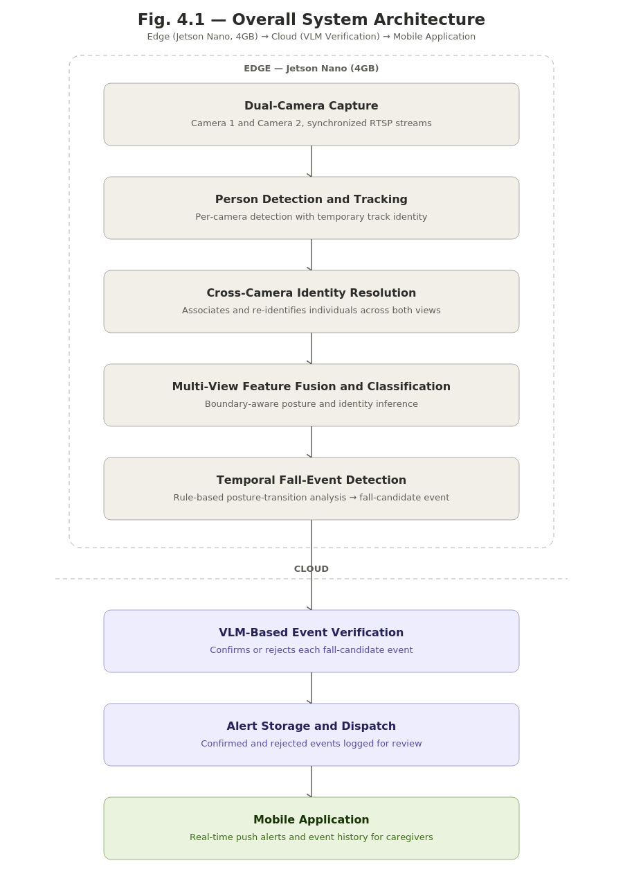
The system is designed as a three-tier distributed architecture, reflecting the practical constraints of a home-based fall monitoring system: real-time visual processing runs locally on the edge device for low latency and network independence, while heavier verification is offloaded to the cloud. The Edge tier, deployed on an NVIDIA Jetson Nano (4GB), captures video from two cameras, detects and tracks individuals, resolves their identity across views, fuses multi-camera features for posture classification, and detects fall events through a temporal rule. The Cloud tier, running on a personal server via Docker Compose, receives events over MQTT, verifies them using the Gemini model, and persists data. The Mobile tier, built with Flutter, delivers real-time alerts and event history to caregivers.
The pipeline begins with two RTSP streams from fixed cameras positioned with partially overlapping fields of view — a deliberate placement, since it is what allows the three technical challenges introduced earlier in this thesis to arise, and to be addressed, within the same system. The streams are batched through a stream multiplexer that preserves source-camera identity per frame, a detail required for every downstream stage to later distinguish and re-associate data from the two cameras.
Person Detection and Tracking (Section 4.2) applies a YOLOv8n detector together with a multi-object tracker (NvSORT) to localize individuals and assign each a temporary, per-camera track identity. Cross-Camera Identity Resolution then determines whether observations from the two cameras, at the same moment, correspond to the same person, using a geometric association step based on floor-plane homography (Section 4.4); when only one camera observes a person at a given time — a common occurrence in a real household rather than a fully-instrumented lab — the system falls back to a single-camera path rather than stalling. Separately, a re-identification mechanism (Section 4.3) recognizes a person who has left both cameras' fields of view and later reappears, using identity embeddings rather than an instantaneous geometric match.
Multi-View Feature Fusion and Classification (Section 4.5) is the core technical contribution of this thesis. A shared feature-extraction backbone, adapted from the existing posture-classification model, processes each camera's crop; when a pair of crops is confirmed to belong to the same person, their features are combined through a cross-camera attention mechanism guided by epipolar geometry, allowing information missing in one view to be recovered from the other before any classification decision is made. The fused representation feeds two output branches (Section 4.6): a Pose Head for posture classification, and a Re-Identification Head producing the embeddings used by the mechanism above.
The resulting posture sequence — unified per person rather than per camera — feeds a State Buffer and a Temporal Rule Detector. Running this temporal analysis after fusion, rather than independently per camera, is deliberate: a fall occurring exactly at the camera boundary might otherwise never produce a valid transition on either view alone, causing a real fall to be missed. A confirmed transition generates a fall-candidate event, packaged with recent frames and published to the Cloud tier over MQTT.
Every fall-candidate event, regardless of confidence, is verified by the Gemini model against its frame sequence, distinguishing genuine falls from visually similar but harmless postures. Verification runs unconditionally rather than being gated by confidence, reflecting a priority on alert accuracy over inference cost. Confirmed events are stored and pushed to the mobile app via Firebase Cloud Messaging; rejected events are retained and labeled for later error analysis.
Sections 4.2 – 4.6 detail each component: 4.2 per-camera detection and tracking, 4.3 cross-camera re-identification, 4.4 floor-geometry identity association, 4.5 epipolar-guided feature fusion, and 4.6 the dual-branch output heads and their loss functions.
4.2. Per-Camera Detection and Tracking
The first stage of the vision pipeline converts each camera's raw video into a set of localized person crops with temporary identity assignments, forming the base data unit for all downstream processing. It runs entirely independently per camera and consists of a detector followed by a tracker.
Detection uses YOLOv8n, the smallest variant in its family, chosen given the strict compute and memory budget of the 4GB Jetson Nano, an older-generation device that must carry the full dual-camera pipeline alongside downstream inference. The model is restricted to a single class — person — filtered from the original eighty-class COCO taxonomy, reducing unnecessary computation. It is exported to ONNX and compiled into a 16-bit TensorRT engine directly on the target device, since a compiled engine is tied to the specific hardware and library version it was built on. The two streams are processed in a batch of size two, matching the number of sources exactly — a detail that directly affects whether inference results are correctly re-associated with their source camera in DeepStream's batched pipeline. The output, per frame per camera, is a set of bounding boxes with detection confidence and source-camera identity attached.
Tracking assigns a temporary identity, maintained continuously per camera, to each detected person. Tracking-by-detection methods generally follow the same cycle each frame: predict each tracked object's position via a motion model (typically a Kalman filter), match predictions against new detections by spatial overlap (typically IoU), and resolve the best assignment via an optimal algorithm (typically Hungarian) — deciding which identities persist, which are newly created, and which are terminated after several unmatched frames.
The tracker initially chosen was ByteTrack, valued in the literature for using low-confidence detections to preserve continuity through brief occlusions. During integration with the DeepStream version in use, however, it caused a memory-access fault that terminated the pipeline — a compatibility issue with that specific platform version rather than a configuration error. The thesis therefore adopted NvSORT, a tracker from the same SORT family pre-optimized within DeepStream's own libraries, restoring stability while preserving the same motion-prediction and spatial-matching principles. A lightweight, platform-native tracker is especially appropriate given the device's limited compute capacity.
The output of this stage, per camera, is a continuously updated stream of identity–bounding-box pairs and corresponding crops, feeding the classification stage that follows. One limitation is deliberately retained here: a tracking identity is valid, and persists, only within a single camera's field of view, and is lost entirely once the person leaves it. This limitation directly motivates the cross-camera re-identification problem addressed in Section 4.3.
4.3. Solution for Re-Identification under Camera Handoff
Architectural Position of the Re-Identification Solution within the Overall Pipeline
The Re-Identification solution is integrated into the Re-ID head branch of the shared Secondary Inference Engine (SGIE) architecture. This module consists of three main components across three distinct yet complementary functional tiers: a shared feature-extraction backbone (a YOLOv8n-cls network extracting visual features from pedestrian image crops); a Re-ID head branch that maps these features into a 256-dimensional, L2-normalized identity-discriminative embedding vector, optimized using Triplet Loss; and a system-level track and gallery management module that compares the embedding of a newly detected subject against the most recent embeddings of recently lost tracks to decide whether to retain an existing track ID or assign a new identity. Because both the embedding and the gallery embeddings are L2-normalized, cosine similarity — the standard matching metric — reduces to a simple dot product, which is cheap enough to compute at scale on the edge device.
Unified Feature Extraction for Re-Identification and Identity Association
The Re-Identification and Identity Association modules share an identical Re-ID head branch; their sole operational difference resides in the track management execution logic. For Identity Association, the system performs embedding association across concurrent observations. For Re-Identification, the system performs association across temporally disjoint observations (when a subject exits Camera 1's field of view and reappears at Camera 2 after traversing a blind zone).
Decoupling Re-ID from the PGIE Backbone
A prevalent paradigm in multi-object tracking is Joint Detection and Embedding (JDE), which appends a lightweight Re-ID branch directly onto the object detector backbone, sharing a single forward pass [16]. FairMOT [17] refined this using the anchor-free CenterNet detector, achieving high accuracy across both tasks. However, as the FairMOT authors demonstrate, this architecture suffers from inherent task competition: detection requires intra-class invariance, whereas Re-ID demands inter-class discriminability; without careful loss-balancing, joint optimization favors detection at the expense of Re-ID quality [17]. For this reason, the Re-ID branch is not attached to the Primary Inference Engine (PGIE) backbone (YOLOv8n); instead, it is isolated within an independent SGIE operating on a dedicated shared backbone downstream of the cross-attention/pairing step. This incurs a second forward pass on the Jetson platform, but the cost remains acceptable since the SGIE only processes cropped bounding boxes, not full frames.
Re-ID Head Training Objective
The Re-ID head is optimized using Triplet Loss with a batch-hard mining strategy: for each anchor a in a batch of size B, the network selects the hardest positive (same identity, largest distance) and the hardest negative (different identity, smallest distance):
L = Σ_{a=1}^{B} [ max_p d(e_a,e_p) − min_n d(e_a,e_n) + α ]₊ (4.1)
where p, n range over same-identity and different-identity samples relative to anchor a, α is the margin (typically 0.2–0.3 per [11]), and [·]₊ = max(·, 0). This batch-hard sampling strategy is shown by [11] to substantially outperform random or offline triplet sampling. Training labels are the track IDs assigned during PFDD annotation.
Track Management and the Re-Identification Decision Rule
When a track disappears from every active camera for more than N consecutive frames (a configurable parameter, consistent with the Temporal Transition Detector's design), it is moved into a temporary gallery G rather than discarded — each entry retaining the track's identity, most recent embedding, last observed posture, and departure timestamp. When a new track appears with embedding e_new, its identity is resolved by first finding the nearest gallery entry, then applying a distance-and-time gate:
k* = argmin_{k∈G} d(e_new, e_k)
ID(new) = { ID_k*, if d(e_new, e_k*) < τ and t_now − t_k* < T_max
{ new ID, otherwise (4.2)
where τ is the distance threshold and T_max the gallery entry's maximum lifespan, corresponding to a plausible transit time between the two indoor cameras. This temporal constraint prevents matching against an unrelated individual who happens to appear much later.
Implementation on Edge and Cloud
Matching is not performed on individual frames but over an accumulation window: each track buffers 5–10 embedding frames (the lower bound ensures sufficient confidence, the upper bound limits latency), which are mean-pooled and L2-normalized before being published over MQTT (topic reid/query) to the cloud tier — this edge-to-cloud query architecture follows the pattern of Yen's MCDPT thesis [26]. If a track's feature state changes mid-accumulation — switching between the single-camera fallback branch and features already fused via the Cross-Camera Attention Fusion module (Boundary Feature Fusion) — the buffer is reset rather than averaging two feature types of different nature. On the cloud side, once a match is found, the gallery embedding is not overwritten but updated via an exponential moving average with update rate β, letting the gallery adapt gradually to appearance drift without discarding prior appearance information. The values currently used in the implementation are τ = 0.6 and β = 0.1 — current codebase defaults, not yet the result of experimental tuning; both will be evaluated and adjusted during the SGIE training/evaluation phase.
Feature Quality Challenges — Camera-Conditional Normalization (Implemented)
Because Re-ID embeddings are learned primarily from visual appearance, matching precision depends on whether two embeddings of the same individual, captured by two different Ezviz camera models (CS-H6C and C6N), are sufficiently similar. This is the "camera bias" phenomenon widely documented in the Re-ID literature: sensor disparities across camera hardware shift the color distribution of the same subject [12], while illumination, background, and camera-response differences introduce a domain gap where intra-class variance often exceeds inter-class variance [13]. To mitigate this, a camera-conditional normalization layer is inserted immediately before the Re-ID head — a narrowed variant of Camera-based Batch Normalization [15] and IBN-Net [14], exploiting the fact that only two fixed cameras are involved: each camera uses its own dedicated BatchNorm parameters, selected by the cam_id already available from the DeepStream pipeline at forward time, rather than a shared normalization statistic or camera-identity inference at inference time. This approach is considerably cheaper than the general-purpose IBN-Net, which is designed to generalize to unseen camera domains. The layer is applied only on the branch feeding the Re-ID head, not the Pose head (Boundary Feature Fusion), since color/illumination normalization carries no posture information.

4.4. Solution for Identity Association

4.4.1. Recap of the Gap
Section 2.3 identified a gap between two extremes: geometric methods that require no training but lack any appearance model [19], and deep-learning methods that achieve high accuracy but demand full calibration, tight synchronization, and substantial hardware [27]. A middle tier explored in the literature review — lightweight graph-based matching such as GNN-CCA [28] — narrows this gap but still introduces a trainable component. The solution adopted here goes one step further: it combines a one-time floor calibration via homography with the Hungarian algorithm [29] for globally optimal cross-camera matching, requiring no training, no learned parameters, and no additional model running on the edge device — trading a measure of accuracy in extreme close-proximity scenarios (quantified in Section 6.5) for zero training cost and full compatibility with the Jetson Nano 4GB compute budget.

4.4.2. Architecture and Formulation
Foot-point projection via homography. For each camera c, let 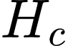 denote its calibrated  homography matrix. Given a bounding box 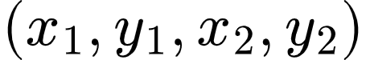, the foot point is defined as:
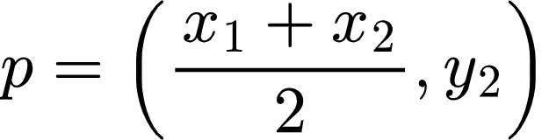
This point is projected onto the shared ground plane as:
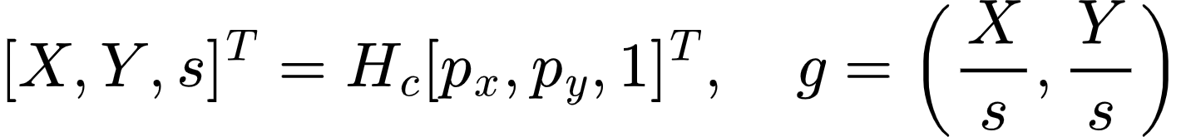
Implementation:homography.py, function project_bbox_foot(). Tested against real EPFL Terrace calibration (4 cameras); projected coordinates matched geometric expectations.
Cross-camera cost matrix and optimal assignment. At time t, let 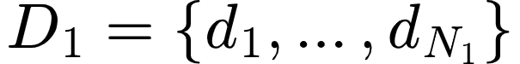 and 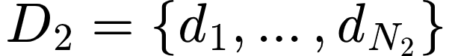 denote the sets of tracks currently held by Camera 1 and Camera 2 respectively, each already projected to ground-plane coordinates via Step 1. A cost matrix C of size 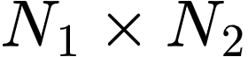 is built, where each entry is the Euclidean distance between the two tracks' ground-plane coordinates:
The Hungarian algorithm [29] is applied to find the assignment  that minimizes total cost over all valid one-to-one pairings:
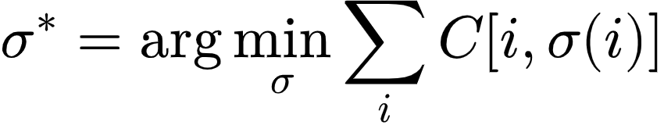
Unlike greedy nearest-neighbor matching, this guarantees a globally optimal solution: no track can "steal" a nearer-but-incorrect match at the expense of leaving a better true match unresolved elsewhere in the frame — a failure mode that becomes increasingly likely as the number of co-present individuals grows.
Threshold-based rejection and global ID assignment. Any matched pair 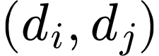 with 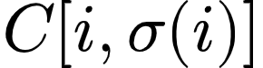 greater than a fixed  is rejected — the two tracks are treated as two different people rather than one. Matched pairs surviving the threshold are assigned a shared global ID; tracks that go unmatched (present in only one camera, e.g. due to occlusion in the other view) are assigned their own individual global ID, corresponding to the single-camera fallback branch shown in Fig. 4.1a.
Implementation: homography_matching.py, functions match_two_cameras() and assign_global_ids(). Tested with a synthetic three-person scenario (one person visible to both cameras, two people each visible to only one camera): the shared individual was correctly merged into a single global ID, and the two single-camera individuals were correctly kept separate.

4.4.3. Threshold Calibration
 is not a learned parameter — it is a single scalar determined empirically from on-site measurements, not assumed. Two quantities are measured directly (Section 6.3 gives the full procedure): a noise ceiling, the largest ground-plane discrepancy observed for the same real person viewed from both cameras across multiple positions, and a danger floor, the smallest real-world distance observed between two different people in realistic close-proximity situations (e.g., seated together, standing at a counter). A safe threshold exists only if the noise ceiling is strictly below the danger floor; the implementation reports both bounds explicitly rather than silently picking a value, so that the absence of a safe margin is surfaced rather than hidden.
Implementation: calibrate_threshold.py. Logic verified with simulated measurement data; awaiting real on-site measurements (Section 6.3) for the final value used in evaluation.

4.4.4. Why This Architecture Fits the Project's Pipeline
It occupies the correct position in the already-designed data flow, and removes a dependency rather than adding one. The overall system diagram (Section 4.1) places Homography Association immediately after the tracker and before SGIE. Because this design uses no appearance information at all, it does not merely avoid restructuring the pipeline — it removes any dependency on SGIE completing first: Identity Association can run and produce a global ID the moment tracking output is available, independent of whether the Re-ID/pose branch has finished its forward pass. This reduces the critical path to the fall-candidate event and decouples the two modules' failure modes.
It requires no appearance feature extraction at all. Because matching relies purely on ground-plane distance, no CNN feature extractor, no embedding, and no Re-ID branch is needed for this module specifically — in contrast to the Re-ID branch inside SGIE, which serves a separate objective (identity association under camera handoff) and is trained independently. This keeps Identity Association fully self-contained: its correctness does not depend on the quality or availability of any learned embedding elsewhere in the system.
Problem size is tightly bounded by the two-camera, small-household setting. The cost matrix has at most  entries, and the Hungarian algorithm runs in polynomial time 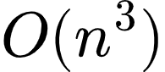 in the worst case for an 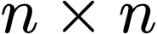 matrix) — for household-scale occupancy (typically 1 to 4 co-present individuals), this is a negligible computation, well within the Jetson Nano compute budget, and orders of magnitude cheaper than running any neural network inference.
It preserves the module boundary established in 2.2. The rationale for separating SGIE from PGIE (following FairMOT) was that detection and Re-ID compete with each other when sharing a backbone. Identity Association runs as an independent step that touches neither PGIE nor SGIE's internals and does not consume their outputs — an even stronger form of separation than a design that reuses SGIE's embeddings would provide.

4.4.5. Design Rationale
The Hungarian algorithm was chosen over both greedy pairwise matching and a learned graph neural network. Greedy matching processes tracks in an arbitrary or confidence-based order and commits to each match immediately, which can leave a later, genuinely closer pair unmatched simply because one of its members was already claimed — the Hungarian algorithm's global optimality guarantee eliminates this failure mode entirely, at negligible extra computational cost for the small N expected in this setting. Relative to a learned approach such as GNN-CCA [28], this design forgoes the ability to fall back on appearance similarity when two people are geometrically close — a known, explicitly measured trade-off (Section 4.4.3, Section 6.5) — in exchange for requiring no training data, no additional model weights on the Jetson Nano, and fully deterministic, reproducible behavior independent of any learned initialization.
4.5. Boundary Feature Fusion
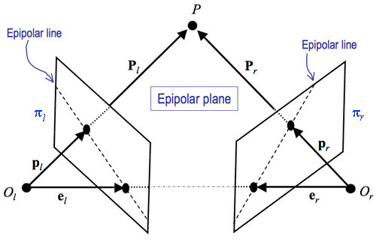
The third research problem addressed by this thesis concerns a scenario in which a person falls precisely at the boundary between the fields of view of two cameras, such that each individual camera observes only part of that person's body. Under such locally incomplete observation, classifying posture based solely on features from a single camera carries a high risk of an inaccurate label. The design adopted here is entirely geometry-driven and contains no learnable parameters within the fusion step itself — a deliberate choice made to avoid the need for synchronized two-camera training data, which the eight-week timeline and available data-collection setup could not reliably provide.
Given two crops of the same person — already matched across cameras via the geometric association step in Section 4.4 — a shared backbone ϕ (a plain YOLOv8n-cls network, without the DCNv2 or EMA modules considered in earlier design iterations) extracts two spatial feature grids F₁, F₂ ∈ ℝ^{h × w × d}, retaining spatial structure rather than collapsing it into a single vector.
Because the system lacks dedicated stereo calibration and cannot compute a true fundamental matrix, correspondence between a position in camera 1's grid and positions in camera 2's grid is approximated using the same floor-plane homography family already established in Section 4.4. Let H_{h} denote the approximate homography for a horizontal plane at height h above the floor, and {h₁, ..., h_{K}} a small set of assumed height levels spanning the typical human body height range. Given grid position i in F₁ and its floor-contact point p_{i} (known from Section 4.4), the corresponding approximate points in camera 2 are:
A least-squares line l_{i} fitted through Q_{i} serves as the approximate epipolar line for position i, replacing a line computed from a true fundamental matrix. For every position j in F₂, the perpendicular distance d(j, l_{i}) to this line is computed, and the fusion weight between query i and key j is a normalized Gaussian function of that distance:
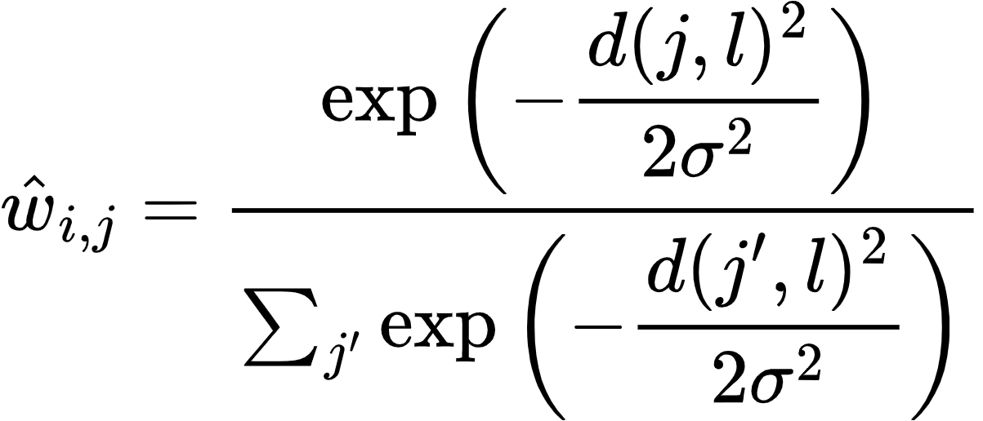
where σ is a fixed hyperparameter controlling the tolerance of the geometric constraint, chosen manually and tuned by visual inspection rather than learned. The enriched feature at position i of camera 1 is obtained by adding a weighted sum of camera 2's raw features — not a learned projection of them — via a residual connection:

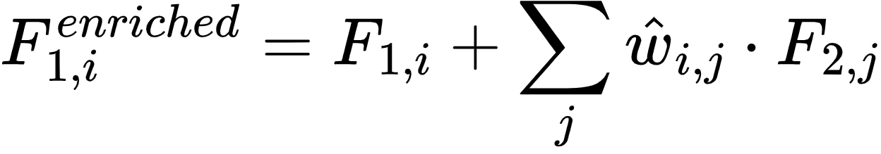
The symmetric computation, with the two cameras' roles reversed, is carried out in parallel to obtain F₂^{enriched}, preserving the bidirectional character of the mechanism. The two enriched grids are pooled and averaged into a single feature vector representing the person, no longer distinguished by camera:

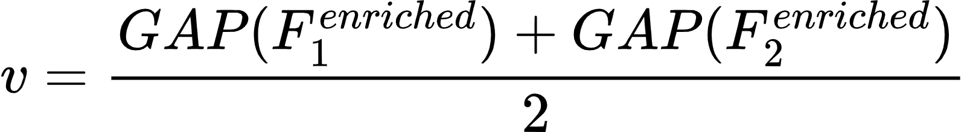
This mechanism is activated only when Section 4.4 confirms both cameras simultaneously observe the person. When only one camera observes them, the system bypasses Equations (4.3)–(4.6) entirely and uses 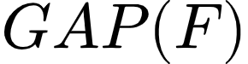 from the single observing camera in place of Equation (4.6). Because no parameter within the fusion block is trained, this fallback path requires no modality-dropout training scheme — there is nothing here for such a scheme to regularize.
The resulting vector  is passed as shared input to the Pose head and Re-Identification head described in Section 4.6. As an acknowledged and as-yet-unverified risk, the Pose head was pretrained on approximately 90,000 single-camera images and reused here without retraining; whether the distribution shift introduced by Equation (4.6) measurably degrades posture-classification accuracy on the fused branch remains an open experimental question, with a bootstrap fine-tuning fallback held in reserve.

4.6. Task Heads and Loss Functions

4.6.1. Overview
Among the three research problems addressed in this thesis, only one component carries a loss function trained as part of this work: the Re-Identification head. Identity Association (Section 4.4) is a purely geometric procedure — floor-plane homography combined with the Hungarian algorithm — and contains no learnable parameters, so no loss function applies to it. Similarly, the fusion step at the core of Boundary Feature Fusion (Section 4.5) is geometry-driven and parameter-free; the only trainable component downstream of it is the Pose head, which is a pretrained single-camera posture classifier reused without retraining for the fusion scenario, and is therefore not a newly trained component of this thesis. This section accordingly describes the loss function of the Re-ID head, then explains why the final fall/no-fall decision is produced by a rule-based temporal check rather than a learned classifier, consistent with the modular, independently-optimized design established in Sections 2.2 and 4.4.4.

4.6.2. Re-ID Head Loss (Serving Re-Identification, Section 4.3)
The Re-ID branch inside the SGIE is trained with Triplet Loss using batch-hard mining [11], as established in Section 4.3. For each anchor  in a training batch, paired with its hardest positive (same identity, maximum distance) and hardest negative (different identity, minimum distance):
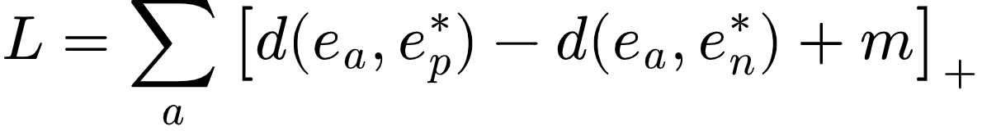
where 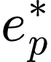 and 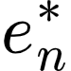 are the hardest positive and hardest negative embeddings for anchor  within the batch, 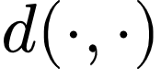 is the Euclidean distance, and 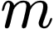 is a fixed margin hyperparameter enforcing separation between same-identity and different-identity pairs. This is the sole loss function trained in this thesis's cross-camera identity pipeline; no other module downstream or upstream of it shares gradients with it or requires a combined weighted loss term.

4.6.3. Final Decision Layer (Fall or No-Fall): Rule-Based by Design
The final fall/no-fall output is not produced by a trained classifier. Each unified person identity (resolved via Identity Association and Re-Identification, so that a fall is attributed correctly even when the person crosses between camera views) maintains a short history of per-frame posture states in the State Buffer. A fall is confirmed when this state transitions from standing or sitting to lying within a fixed duration threshold, set to .
This is a deliberate design decision, not a shortcoming: a rule-based temporal check requires no additional training data, no additional model to run on the Jetson Nano, and adds negligible latency compared to a learned temporal classifier (e.g., an LSTM head), while still filtering out single-frame detection noise that a per-frame-only rule would miss. The trade-off — some sensitivity to threshold tuning, and no learned adaptation to individual movement patterns — is accepted here in exchange for predictable, low-latency behavior on constrained hardware. Final confirmation before an alert is sent is additionally delegated to the cloud-based VLM verification step (Section 5.2), which absorbs the residual false-positive risk that a purely rule-based edge decision cannot fully resolve on its own.

5. SYSTEM IMPLEMENTATION AND DEPLOYMENT
5.1. Edge Pipeline Implementation on Jetson Nano
The edge subsystem is implemented on an NVIDIA Jetson Nano (4GB) running JetPack 4.6, using the corresponding DeepStream release for this platform generation (DeepStream 6.0.1) together with CUDA 10.2 and TensorRT 8.2. All inference-path components are implemented as a single GStreamer pipeline constructed and controlled through the Python bindings for the DeepStream metadata API, chosen over the C/C++ application framework in order to allow the fall-detection logic, MQTT integration, and pipeline control code to reside in the same language and codebase, simplifying iteration during development.
The pipeline is constructed as a linear graph of GStreamer elements reflecting the architecture described in Chapter 4. Two RTSP source elements, one per camera, feed into a stream multiplexer element configured with a batch size of two, matching exactly the number of input sources; this batch-size configuration is not incidental, since a mismatch between batch size and the number of active sources is a common source of silent metadata misalignment in DeepStream pipelines, where inference results can be attributed to the wrong source stream if the batching configuration does not correspond to the actual number of muxed inputs. The muxed batch is passed to a primary inference element running the YOLOv8n person detector, followed by the NvSORT tracker, which assigns a temporary per-camera track identity to each detected person. This per-camera identity is then resolved by the Identity Association stage described in Section 4.4: the floor-contact point of each track is projected through the pre-calibrated homography and matched, via the Hungarian algorithm, against tracks observed in the other camera, yielding a determination of whether the two cameras are simultaneously observing the same individual.
The result of this association gates the behavior of the shared secondary-inference backbone. When a person is associated across both cameras, the corresponding crops from both views are passed through the shared YOLOv8n-cls backbone and combined via the Boundary Feature Fusion mechanism of Section 4.5, whose grid-preserving output is enriched using the geometry-derived fusion weights before being pooled into a single feature vector. When a person is observed by only one camera, the backbone output for that camera is pooled directly, bypassing the fusion step, consistent with the single-camera fallback path of Section 4.5. The resulting vector is passed in parallel to the Pose head, described in Section 4.6, and to the Re-Identification head of Section 4.4, whose embedding is used for gallery matching once sufficient frames have accumulated in the per-identity buffer.
A probe function attached downstream of this stage extracts the resulting per-object metadata — posture label, confidence, unified identity, source camera index, and bounding box coordinates — for consumption by the State Buffer and Temporal Rule Detector, keyed by the unified cross-camera identity rather than by any single camera's local track identity, exactly as described in Section 4.1. Because the pipeline's purpose at this stage is metadata extraction rather than visual output, the terminal element of the main inference path is a null sink, avoiding the additional computational cost of on-screen display composition and video encoding for a pipeline branch whose output is not intended for direct viewing.
Both the primary detector and the shared secondary backbone are deployed as TensorRT inference engines rather than through a general-purpose deep learning runtime, in order to exploit the hardware-accelerated inference capability available on the Jetson platform. Each model was exported from its native training representation to the intermediate ONNX format, then compiled into a TensorRT engine using 16-bit floating-point precision directly on the target Jetson device, since a TensorRT engine is tied to the specific GPU architecture, driver, and library version on which it was built. The primary detector is configured to recognize a single object class, filtered from the eighty-class taxonomy on which the base YOLOv8n architecture was originally trained, reducing both the output tensor size and the per-frame post-processing cost. The shared secondary backbone operates on a fixed six-class posture taxonomy, invoked per detected person crop.
The multi-object tracker component required a deployment-time substitution not anticipated at the design stage. The tracker initially selected, ByteTrack, is widely reported in the tracking literature for its ability to exploit low-confidence detections to preserve track continuity through brief occlusions, and was accordingly the initial choice for this pipeline. During integration on the DeepStream release running on the target device, however, this tracker implementation produced a segmentation fault that terminated the pipeline process, an issue traced to a compatibility conflict between the external tracker library and the specific DeepStream runtime version in use rather than to any misconfiguration on the application side. Given the deployment timeline, the practical resolution adopted was to replace ByteTrack with NvSORT, a tracker from the same detection-based tracking family that is distributed and pre-validated as part of the DeepStream platform's own library set. This substitution restored pipeline stability without requiring changes to any downstream component, since both trackers expose the same per-object track-identity metadata to the rest of the pipeline.
Because the main inference pipeline terminates in a null sink and produces no visual output by design, a separate diagnostic pipeline, visual_dump.py, was implemented to make the model's behavior inspectable during development. This diagnostic pipeline branches the video path after the secondary inference stage into a rendering path that overlays the predicted identity and posture label onto each frame and periodically writes annotated JPEG snapshots to local storage, optionally publishing them to a dedicated MQTT topic kept separate from the topic used for actual fall events, so that visual debugging traffic can never be mistaken for, or interfere with, operational alert traffic. Constructing this diagnostic branch surfaced two concrete pipeline-engineering problems that are recorded here because both are representative of issues likely to recur in similar DeepStream deployments rather than being specific to this project alone. First, an element used to enforce a fixed output frame rate failed to negotiate a compatible media format with the upstream elements, because the live RTSP sources do not declare a fixed frame rate in their stream metadata, a property that this element requires in order to operate; the resolution was to remove this element from the pipeline and instead implement frame-rate limiting as a custom probe function that selectively drops buffers, which does not depend on an advertised frame rate. Second, after resolving the negotiation failure, the pipeline exhibited severe throughput degradation, with the visible frame rate dropping to a small fraction of its expected value; the cause was traced to the CPU-bound rendering and JPEG-encoding branch applying backpressure that propagated upstream through the pipeline as far as the hardware video decoder, stalling the entire pipeline rather than only the diagnostic branch. This was resolved by inserting a leaky queue element, configured to silently discard the oldest buffered frame under backpressure rather than blocking, immediately after each camera's output pad following the stream demultiplexer, which decouples the diagnostic rendering path onto its own thread and allows it to drop frames under load without stalling the primary inference path.
The temporal fall-detection logic, corresponding to the State Buffer and Temporal Rule Detector described in Section 4.1, is implemented as a pure Python module with no dependency on the DeepStream runtime, GStreamer, or GPU access. This separation was a deliberate implementation choice: because the rule governing when a sequence of posture labels constitutes a fall candidate is a matter of temporal logic operating on already-extracted, identity-resolved labels, isolating it from the video pipeline allows it to be exercised by an automated test suite on any machine, without requiring a camera, a GPU, or a running DeepStream pipeline. The test suite covers the required behavioral cases directly: a genuine transition from standing or sitting to lying within the configured time window must trigger a candidate event; a person already lying down at the start of observation, with no preceding standing or sitting anchor, must not trigger one; and a deliberate sit-down motion must not trigger one either. Additional cases cover noise rejection through a minimum consecutive-frame confirmation requirement before a posture label is trusted, a cooldown period preventing repeated events for a person who remains on the floor, and independent handling of multiple simultaneous identities. At the time of writing, all cases in this suite pass, providing a verified, GPU-independent behavioral baseline for the temporal logic.
Event delivery from the edge device to the cloud tier is implemented over MQTT using a persistent client connection established once at pipeline startup rather than reconnected per event, with automatic reconnection handling for transient network loss. Fall-candidate events are published with quality-of-service level one, guaranteeing at-least-once delivery given the operational importance of not silently losing an alert, whereas periodic telemetry messages are published with quality-of-service level zero, since an occasional dropped heartbeat carries no operational consequence. To validate this integration path independently of the completeness of the vision pipeline, a synthetic event generator was implemented that constructs a schema-valid fall event, including a placeholder frame sequence, and publishes it directly to the broker; this tool was used to verify that a correctly formatted event published from the edge device is received intact by a subscriber on the cloud side, including over the actual public network path to the cloud tier's broker rather than only on a local loopback interface.
Development and integration testing were conducted against a simulated pair of RTSP sources rather than the physical cameras for the majority of the implementation period, since the target cameras remained inaccessible to the Jetson device across the deployment network topology at the time of writing. The simulated sources were produced by looping a recorded test video through a locally hosted media server and exposing it as two independent RTSP endpoints, allowing the complete pipeline, from stream ingestion through identity resolution, fusion, classification, temporal detection, and MQTT publication, to be exercised end-to-end under realistic streaming conditions without depending on the resolution of the underlying network access issue.

5.2. Cloud-Based Verification and Alert Delivery

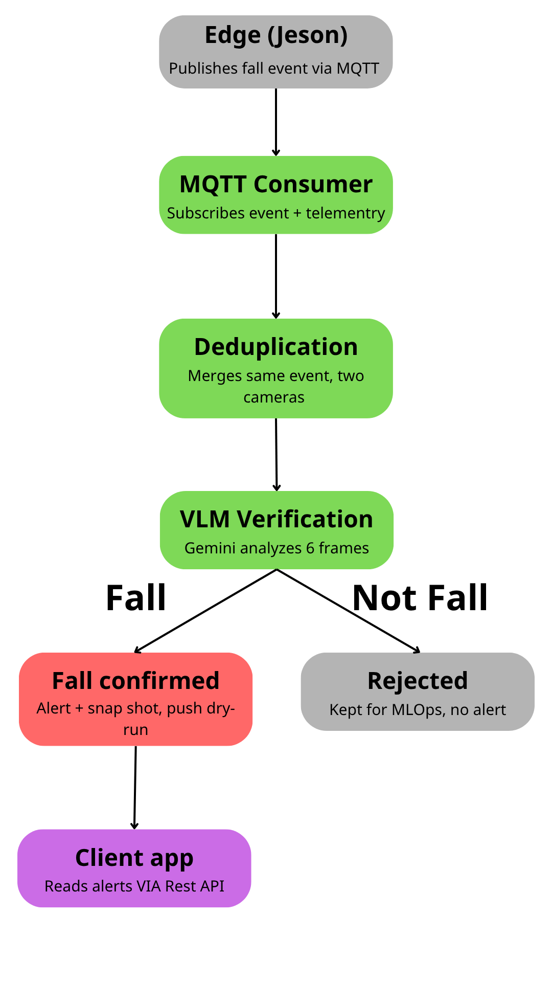
Overview. The cloud tier is implemented as a FastAPI application (fall_backend) deployed alongside PostgreSQL, RabbitMQ with the MQTT plugin, MinIO, and MediaMTX via Docker Compose. It carries two responsibilities: verifying candidate fall events forwarded by the edge pipeline, and making confirmed alerts available to caregivers. A single background MQTT consumer thread, started during the FastAPI application's lifespan, subscribes to events/+/fall and telemetry/+/status; no additional worker or scheduler process exists, so all downstream processing — deduplication, VLM verification, alert persistence — executes synchronously within this one consumer's message-handling path.
Cross-camera deduplication. Candidate events arriving from two cameras within the configured time window are merged into a single event prior to verification, preventing duplicate VLM calls and duplicate alerts for the same physical fall. This is confirmed by two independent evidence sources: production data (four events with status = "merged", timestamped within the same two-second window) and a fresh assertion-based test conducted during the most recent backend review — two events published 0.5s apart from separate cameras correctly produced status = "merged" with an accurate cross-reference note, a stronger form of evidence than the project's existing test_dedup.py, which prints event status for manual inspection without automated assertions.
VLM verification. Each surviving candidate event is verified by Gemini through verify_fall(), which accepts a single image or a 6-frame temporal sequence and always returns a structured result rather than raising an exception, falling back to a fixed dry-run verdict when no API key is configured. The codebase's hardcoded default — GEMINI_MODEL = "gemini-2.0-flash" — points to a model since discontinued by Google; the deployed .env configuration overrides this to gemini-3.1-flash-lite, an actively supported model. Production data quantifies correct end-to-end operation: six events carry vlm_verdict = "fall" with confidence = 0.95, alongside fifteen events with vlm_verdict = "uncertain" — a value the dry-run path can never produce, confirming these are genuine, non-dry-run Gemini responses. A previously identified traceability gap — no record of which model version produced a given verdict — was closed during the most recent backend review: a write to the confidence_log table was added immediately after each verify_fall() call, capturing model version, inference latency, and a retrain-flag, validated with a live Gemini call. That same validation call recorded an inference latency of 4.71 seconds, exceeding the pipeline's internal 3-second target — a single data point rather than a systematic measurement, but one that motivates a dedicated VLM latency benchmark (mean, p95) in the Week 7 evaluation rather than relying on the original design target alone.
Alert persistence and retrieval. Confirmed events produce an Event/Alert pair linked by foreign key, retrievable via GET /api/alerts, GET /api/alerts/{alert_id}, and acknowledgeable via PATCH /api/alerts/{alert_id}/acknowledge — closing an earlier gap in which alert records existed in the database but could not be read back by a client. This retrieval API is the sole mechanism by which the mobile app or dashboard surfaces confirmed alerts to a caregiver; the client is expected to poll or refresh this endpoint to view new alerts.
MLOps data capture. Two previously conflated mechanisms are now distinguished. False-positive clip archival — ZIP-archiving the 6 frames of a rejected candidate to MinIO — remains code-confirmed but not yet exercised end-to-end, since no VLM rejection has occurred in production data to date. The confidence_log table, previously unimplemented, now has an active write path (see VLM verification above) and has been validated with a real record.
Operational endpoints. Beyond the core event/alert flow, the API exposes camera management, a runtime-configurable detection rule set, per-camera telemetry, a live-view endpoint that returns a constructed MediaMTX HLS URL for direct client playback, and liveness/readiness health probes for future orchestration. Rule tuning without redeployment applies fully to values persisted in the database; a smaller subset of pipeline-wide toggles is held in-process and reverts to hardcoded defaults on restart. A latent bug in the readiness probe's connection-pool sub-check, which silently failed on every invocation due to a nonexistent SQLAlchemy attribute, was identified and corrected during the same review.

6. EXPERIMENTAL RESULTS AND DISCUSSION

6.1. Dataset and Exploratory Data Analysis

Overview of Multi-Task Dataset Taxonomy
To rigorously evaluate the proposed multi-camera edge-cloud fall detection system and address three real-world multi-camera vision challenges Re-Identification, Identity Association, and Boundary Feature Fusion — a comprehensive multi-tier dataset taxonomy is established.Rather than relying solely on single-camera static images or uniform benchmark video sequences, our experimental strategy categorizes datasets into three operational functional tiers based on their specific roles within the edge-cloud pipeline:
Model Training Datasets: Used exclusively for offline training and validation of the core deep learning inference modules. This tier includes the custom v4_split_flat posture dataset (for training the Secondary Guidance Inference Engine - SGIE posture classification backbone) and the large-scale MSMT17_V1 dataset (for metric learning and embedding extractions in the Re-Identification module).
Public Benchmark Datasets: Incorporating widely recognized public fall detection datasets (URFD and MCFD) to establish standard baseline performance comparisons against existing single-camera and multi-camera state-of-the-art approaches (e.g., the PIFR baseline).
Custom Self-Recorded Multi-Camera Evaluation Dataset (PFDD-Test): A specialized, real-world multi-camera dataset designed specifically to stress-test and evaluate our system against the three target edge-cloud multi-camera challenges (Re-Identification, Identity Association, and Boundary Feature Fusion). Recorded using synchronized dual EZVIZ IP cameras (CS-H6C and C6N) on an edge-cloud deployment testbed, this dataset models complex indoor topologies, physical deadzones, overlapping FoVs, and boundary occlusions.

Model Training Datasets (v4_split_flat & MSMT17)
Posture Classification Backbone Model Dataset (v4_split_flat): The core posture classification model deployed within the Secondary Guidance Inference Engine (SGIE) relies on a plain YOLOv8n-cls network architecture. To train this classification backbone offline, we utilize the custom v4_split_flat dataset. The dataset provides a comprehensive representation of human body poses across six target classes: Bend, Exercise, Lie, Sit, Stand, and Half_Person (a specialized guard class designed to handle partial body occlusions at camera boundaries). The dataset consists of approximately 100,000 training images (a balanced distribution of 20,000 images per posture category) and a separate validation split of approximately 15,000 images extracted across varied environmental conditions, clothing styles, and lighting setups. Training the YOLOv8n-cls backbone on v4_split_flat enables robust multi-class posture feature extraction prior to temporal rule evaluation.
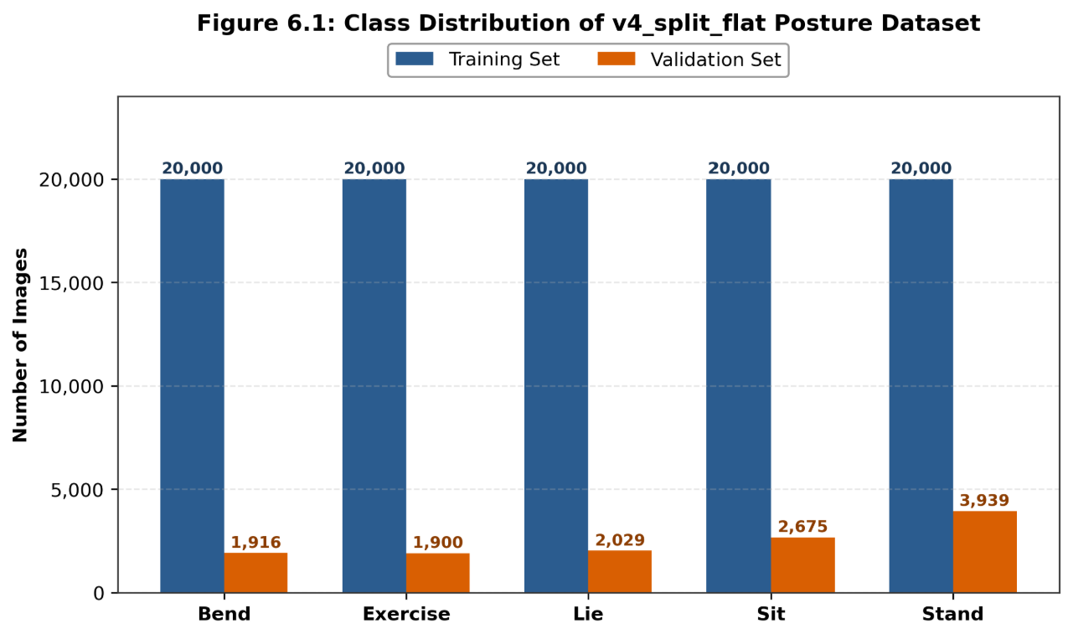

Figure 6.1. Class Distribution of v4_split_flat Posture Dataset

Re-ID Head Branch Fine-Tuning Dataset (MSMT17_V1): To address Re-Identification without incurring the severe memory overhead of running an independent Re-ID neural network on the NVIDIA Jetson Nano, our architecture attaches a dedicated Re-ID Head Branch directly onto the shared SGIE YOLOv8n-cls backbone. Rather than training a standalone object detector or classifier from scratch, the MSMT17_V1 dataset is used strictly to train and fine-tune this 256-dimensional L2-normalized Re-ID embedding head using Triplet Loss with Batch-Hard Mining. MSMT17 comprises 126,441 bounding box images spanning 4,101 unique person identities captured across 15 indoor and outdoor camera views. This training regime optimizes the Re-ID head to project pedestrian appearance features into a discriminative metric space, enabling accurate cosine similarity matching when individuals re-emerge after traversing physical camera deadzones.

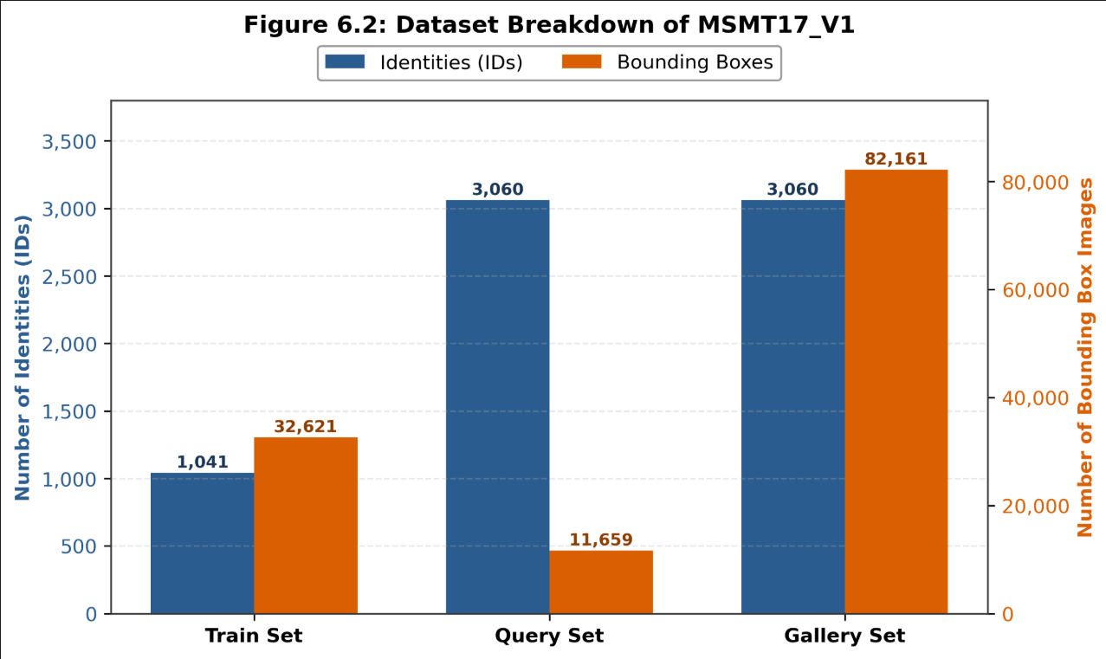
Figure 6.2 MSMT17 Dataset Breakdown for Re-ID Model Training

Public Benchmark Datasets (URFD & MCFD)
To evaluate the baseline performance of our posture classification backbone and temporal fall reasoning logic on standard benchmark streams, two widely recognized public fall detection datasets are incorporated: the University of Rzeszow Fall Detection (URFD) dataset and the Multiple Cameras Fall Dataset (MCFD).
URFD Dataset: Contains 70 video sequences (30 fall events and 40 Activities of Daily Living - ADLs) recorded in a controlled indoor environment, providing an established benchmark for single-camera sequence classification. MCFD Dataset: Released by the University of Montreal, consisting of 176 multi-view video sequences across 24 distinct scenarios recorded simultaneously by 8 IP cameras, serving as a standard benchmark for multi-view fall detection under varied horizontal and vertical camera angles.
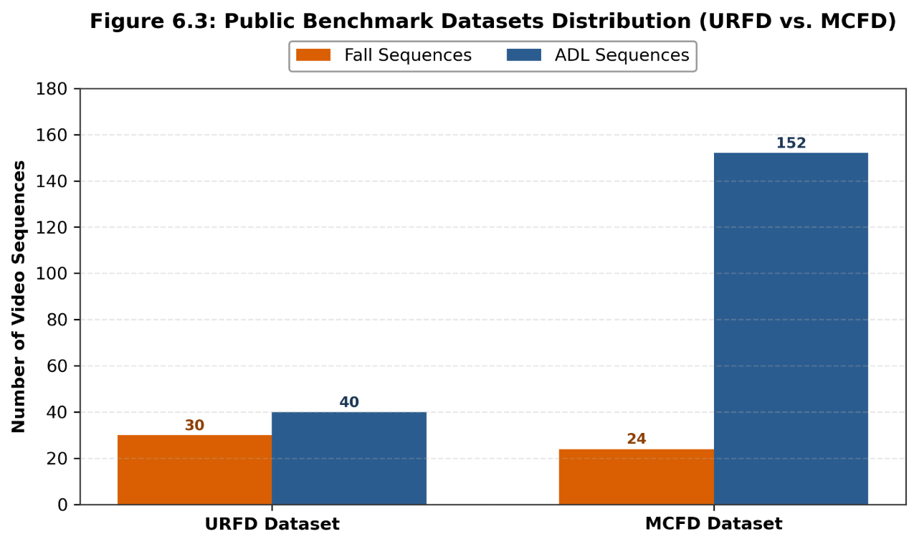

Custom Self-Recorded Multi-Camera Evaluation Dataset (PFDD-Test)
To rigorously evaluate the end-to-end performance of our multi-camera fall detection pipeline under real-world physical boundary conditions, a custom self-recorded evaluation dataset—designated as PFDD-Test—was constructed on our local edge-cloud deployment testbed. The physical testbed comprises two synchronized EZVIZ IP cameras (CS-H6C and C6N) deployed across an indoor spatial topology featuring overlapping visual zones and blind physical deadzones.
The PFDD-Test dataset is structured into three primary functional evaluation sections (P1, P2, and P3). Each section encompasses multiple distinct Data Types, where each Data Type consists of multiple test Scenes captured simultaneously via dual-camera streams (Camera 1 & Camera 2) or single-camera streams depending on the scenario's coverage requirements.

Part 1: Re-Identification Across Physical Deadzones
This evaluation subset explicitly tests feature embedding stability and person identity persistence when subjects navigate unmonitored spatial deadzones between non-overlapping camera fields of view (FoVs). The subset consists of 15 multi-camera test scenes structured into two primary Data Types:
Data Type 1.1: Standard Deadzone Traversal Data (Single-Person)
Description: Captures test scenes where a single subject exits Camera 1's FoV, traverses an unmonitored corridor (deadzone) for 3–8 seconds, and re-emerges into Camera 2's FoV wearing identical attire. Stream Format: Dual-camera synchronized streams (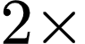 cameras per scene).
Data Type 1.2: Multi-Angle Spatial Perspective Data (4 Body Aspects)
Description: Includes targeted test scenes where the subject re-emerges into Camera 2's FoV presenting four distinct body orientations relative to the camera lens: Front view (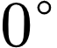), Left profile (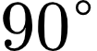), Right profile (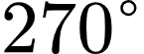), and Back view (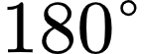). This evaluates the 256-dimensional Re-ID embedding head's robustness against severe spatial perspective shifts after exiting physical deadzones. Stream Format: Dual-camera synchronized streams ( cameras per scene).
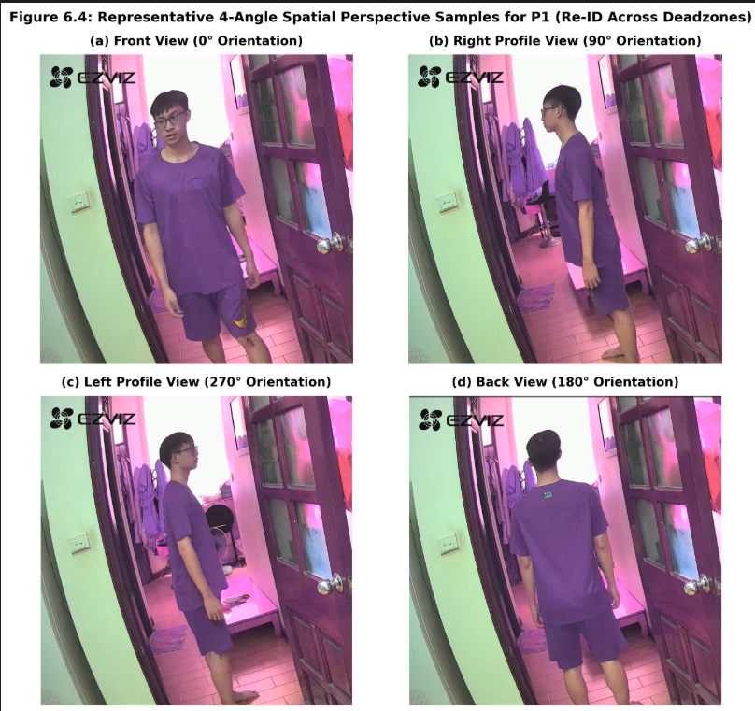
Figure 6.4: Representative 4-Angle Spatial Perspective Samples for P1 Re-ID Scenarios

Part 2: Identity Association Under Overlapping FoV
This evaluation subset assesses the system's ability to associate multi-camera feature embeddings, perform spatial mapping, and suppress duplicate tracklets when subjects move within shared camera coverage zones. The subset consists of 15 multi-camera test scenes structured into three primary Data Types:
Data Type 2.1: Spatial Calibration & Overlap Grid Data (0.7m Grid Boundaries)
Description: Captures test scenes where a subject stands sequentially at four designated spatial vertices of a  ground grid positioned squarely within the overlapping FoV of both EZVIZ cameras. This provides ground-truth spatial landmarks to evaluate cross-camera spatial projection and bounding box alignment. Stream Format: Dual-camera synchronized streams ( cameras per scene).

Data Type 2.2: Single-Subject Continuous Overlap Trajectory Data
Description: Features scenes where a subject walks continuously through the shared visual zone under varying angles and speeds, validating real-time tracklet binding and feature association. Stream Format: Dual-camera synchronized streams ( cameras per scene).
Data Type 2.3: Multi-Person Crossing & Duplicate Suppression Data
Description: Comprises test scenes with two subjects crossing paths within the overlapping FoV, testing global identity assignment accuracy without ID swaps or duplicate entity creation. Stream Format: Dual-camera synchronized streams ( cameras per scene).
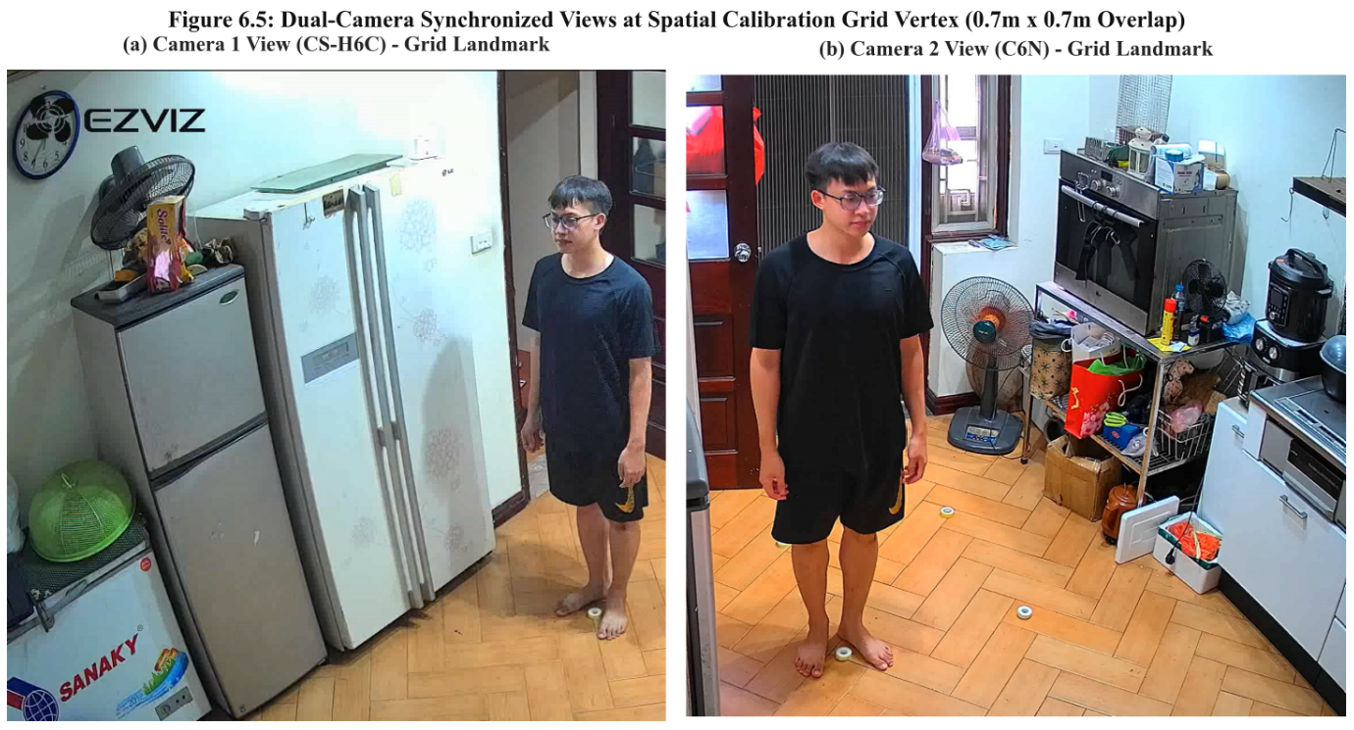
Figure 6.5: Dual-Camera Perspective at Calibration Grid Vertex in Overlap Zone

Part 3: Boundary Feature Fusion Under Partial Body Occlusion (P3)
This evaluation subset stress-tests multi-view posture classification accuracy when subjects experience severe spatial truncation or occlusion at physical camera field of view (FoV) boundaries during fall events. The subset consists of 20 multi-camera test scenes structured into two primary Data Types:
Data Type 3.1: Spatial Boundary Fall Events (Severe Body Truncation)
Description: Captures simulated fall events occurring directly at the spatial edge/boundary of Camera 1's FoV (where lower limbs or torso are cut off in Camera 1), while Camera 2 captures a complementary side-view observation of the exact same event. Stream Format: Dual-camera synchronized streams ( cameras per scene).
Data Type 3.2: Occluded Posture & Furniture Truncation Fall Events
Description: Includes fall events taking place behind static indoor obstacles (e.g., tables, chairs, or sofas) near camera edges, causing significant physical body occlusion in one camera view while remaining fully observable in the alternate camera view. Stream Format: Dual-camera synchronized streams ( cameras per scene).
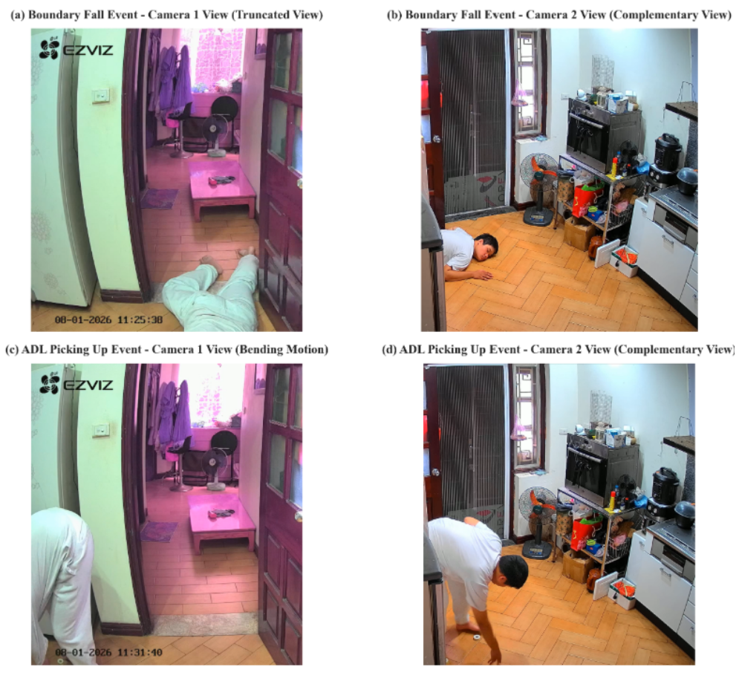
Figure 6.6: Dual-Camera Synchronized Samples Across Boundary Fall Scenarios for P3

6.2. Evaluation Metrics
P1 (Re-Identification) is evaluated in two tiers. Tier 1 reports Rank-1, Rank-5, and mean Average Precision (mAP) on the standard closed-set MSMT17 benchmark, allowing direct comparison against literature figures for the same pretrained backbone. Tier 2 reports True Positive Rate (TPR): the fraction of correctly resolved gallery-matching cases when the full pipeline — feature extraction, buffering, gallery comparison, matching — runs on footage recorded from the two deployed cameras.
P2 (Identity Association) is evaluated using the same clustering-metric family reported by Luna et al. (2022, GNN-CCA) in Table V of their paper — Adjusted Rand Index (ARI), Adjusted Mutual Information (AMI), Homogeneity, Completeness, and V-measure — computed per frame and averaged, so the comparison against that baseline stays methodologically consistent rather than adopting a metric more favorable to this thesis.
P3 (Boundary Feature Fusion) is reported at two levels that are not interchangeable. Frame-level Sensitivity, Specificity, and Accuracy treat each frame as an independent decision. Scene-level Sensitivity, Specificity, and Accuracy apply the windowed OR logic the deployed system actually uses — a scene counts as detected once any single window reports “lie” — and is therefore the primary figure used for baseline comparison. Average classification confidence before and after fusion, and the rate at which fusion changes the predicted class, are additionally reported to confirm the mechanism has a measurable effect rather than adding noise.
End-to-end metrics — frames per second (FPS), peak RAM, device temperature — are measured on the Jetson Nano 4GB under the worst case where every relevant model runs on every frame.

6.3. Implementation Details
Common experimental protocol. All three problems are evaluated on the Jetson Nano 4GB (JetPack 4.6, CUDA 10.2). Test sets share a common augmentation protocol — brightness, darkness, noise, and compression variants — applied consistently to test robustness. Geometric augmentations (flip, rotate, crop) are deliberately excluded for P2 and P3, since both depend on floor-plane homography calibrated to fixed pixel coordinates; P1, being purely appearance-based, additionally includes a flip variant.
Problem | Parameter | Value
P1 | Re-ID model | OSNet x0.5 (~0.6M params), pretrained on MSMT17, used as-is
P1 | Detector input | YOLOv8n at 320×320
P1 | Gallery match threshold | 0.6 (cosine similarity on L2-normalized embeddings)
P1 | Embedding buffer | 5–10 frames, mean-pooled and L2-normalized
P2 | Floor calibration | one-time 4-point homography, 0.7 m reference square
P2 | Matching threshold | 0.5 m (ground-plane distance)
P2 | Test set | P2 Data 3, 4 scenes × 5 variants = 840 frames
P3 | Fusion weight | Gaussian, σ = 2.0 (selected via sweep)
P3 | Height levels | 8 levels, 0–2 m
P3 | Cross-camera pairing threshold | 1.5 m
P3 | Test set | P3 Data 1+2, n=165 matched frames
Table 6.1 — Experimental parameters used for evaluation, by problem.
Note. P1's deployed Re-ID model is OSNet x0.5, run as an independent network — not the shared-backbone SGIE Re-ID head described in Section 4.3. This follows directly from the comparison in Section 6.4.1/6.5.1: the shared-backbone design failed outright on real gallery matching (0% TPR across all configurations tested), while OSNet x0.5 reached 84%. The parameters above reflect the architecture actually deployed and measured.

6.7. Discussion
Camera-conditional appearance drift. All of P1's matching errors (4 of 25 cases) occurred on one camera, never the other, consistent with the camera-bias phenomenon already discussed in Section 4.3 — though whether the camera-conditional normalization described there is actually present in the deployed OSNet pipeline is unclear given the architecture substitution noted in Section 6.3, and should be verified before the claim is repeated in the discussion of results.
Occlusion as a detection-layer, not matching-layer, problem. P2's Scene 3 shows identical accuracy (74.3%) whether matching uses Hungarian or a naive threshold, since no assignment algorithm can recover an identity that was never detected in the first place.
Generalization fragility in learned baselines versus training-free design. The Espinosa (2019) baseline for P3 dropped from 95.64% accuracy on its original dataset, to 82.84% on the same-distribution MCFD test split, to 46.7% on the team's own P2/P3 data — a direct empirical illustration of why a model trained on one camera setup does not transfer to another, and a contrast with P3's fusion mechanism, which needs no retraining for the team's own camera geometry.
A deliberate sensitivity–specificity trade-off, most visible in P3: scene-level sensitivity reaches 100% while specificity is only 41.7%, because the system favors false alarms over missed falls — appropriate for an elderly-fall context, but leaving room for a secondary temporal filter to reduce false alarms without sacrificing sensitivity.

6.4 Baseline

Baseline for Re-Identification under Camera Handoff – Shared Backbone
The baseline model utilizes a Shared Backbone approach, which repurposes the YOLOv8n-cls backbone originally trained for the Pose Head and attaches a custom-developed Re-ID Head consisting of Linear, BNNeck, and Classifier layers. To ensure a fair and standard-compliant comparison, we re-trained this architecture on the MSMT17 dataset across four distinct configurations (varying frozen/unfrozen states and loss functions) and manually benchmarked our evaluation logic against the original torchreid library functions to guarantee that the low performance metrics (Rank-1 < 5%) were accurate and not due to implementation errors. This rigorous setup proves that the failure was due to the backbone being overly specialized for pose features, which led it to ignore critical identity-related visual details.

Baseline for GNN-CCA (Luna et al., 2022)
Baseline. GNN-CCA (Luna, SanMiguel, Martínez, Carballeira, “Graph Neural Networks for Cross-Camera Data Association,” IEEE TCSVT 2022; arXiv:2201.06311) was chosen because it represents the exact graph-learning direction the team considered and rejected early in the project under the “no additional model on Jetson Nano 4GB” constraint, turning that design decision into a measured claim rather than an assumption.
Reimplementation. The official public implementation was obtained and read directly. Architecture: each frame becomes a graph — every detection a node, every cross-camera pair an edge; node features come from a CNN Re-ID extractor, edge features from appearance distance and homography-projected spatial distance; a Message Passing Network propagates information across the graph; edges are classified active/inactive; Connected Components produces the final identity clusters.
What could and could not be run. The full learned model could not be trained or run on the team's data or hardware, for two documented reasons: it requires labeled training data — the same burden that excluded GNNs from the design at the outset — and it depends on PyTorch Geometric together with pytorch-scatter/sparse/cluster, compiled CUDA extensions with no prebuilt wheel for the Jetson Nano 4GB's JetPack environment (Python 3.6.9, CUDA 10.2). What was run successfully is the lightweight, non-learned geometry_association function from the same official codebase — the same baseline GNN-CCA's own Table V reports — executed on the team's real P2 data.
Literature numbers are cited directly from Table V of Luna et al. (2022), measured on the EPFL multi-camera pedestrian dataset (Terrace, Laboratory, Basketball scenes, up to 9 people across 4 cameras — a substantially harder setting than this thesis's 1–2 people across 2 cameras), averaged over three train-test splits, using a ResNet50 Re-ID backbone pretrained on Market1501, CUHK03, and DukeMTMC.

Method | ARI | AMI | Homogeneity | Completeness | V-measure
Geometry-only (non-learned) | 43.49 | 55.40 | 52.48 | 99.03 | 60.96
Geometry+Appearance (threshold) | 57.22 | 65.52 | 80.02 | 82.04 | 78.45
GNN-CCA full (learned) | 84.76 | 87.65 | 93.81 | 92.53 | 93.00
Table 6.2 — GNN-CCA baseline, literature-reported results on EPFL (Luna et al., 2022, Table V).
Estimated Jetson cost (informed estimate, not a direct benchmark): the Message Passing Network itself is light (~0.2M params, per the paper), but GNN-CCA requires a CNN Re-ID extractor on every detection, both cameras, every frame — the same category of cost measured directly in P1, where even the lightest OSNet variant dropped FPS to 18.15 for a single camera and person. P2's actual pairing step (pure NumPy/SciPy Hungarian, no CNN) measured 9.6 ms for 100 iterations of a worst-case 10×10 pairing.

Baseline for Multi-View Feature Fusion for Fall Posture Classification – Feature Fusion
The baseline for this component is the Feature Fusion mechanism via Fused Feature Vectors, which utilizes features extracted directly from the Shared Backbone architecture. To ensure a fair comparison, we re-implemented the fusion logic and modified the YOLOv8n-cls backbone's output layers to extract the specific feature vectors required for the multi-camera pipeline, while strictly verifying our implementation against torchreid standards. The experimental results showed a total failure (0% TPR), confirming that because the backbone was heavily specialized for pose classification, the fused vectors lacked the discriminative identity information needed for effective cross-camera fusion.

6.5 Results
This section reports the final performance figures for the three technical problems against their respective baselines, drawn from the group's own test data and, where a re-implemented baseline exists, from that baseline run on the same data. Full demonstration videos are kept in the Appendix; only representative still frames are referenced here.

Re-Identification (under Camera Handoff)
Table 6.1 compares the adopted OSNet x0.5 design against the shared-backbone design that the group implemented first and subsequently rejected on experimental grounds.
Metric | OSNet x0.5 (Ours) | Shared Backbone (Baseline)
Rank-1 (MSMT17) | 71.14% | 3.48% – 4.88% (best of 4 configs)
mAP (MSMT17) | 41.99% | 0.78% – 1.11%
TPR, Tier-2 base cases (n=4) | 75.0% (3/4) | 0.0% (0/4)
TPR, Tier-2 full case set (n=25) | 84.0% (21/25) | 0.0% (0/25)
FPS on Jetson Nano 4GB (with YOLOv8n) | 18.15 | not measured
Table 6.1 – Re-Identification: OSNet x0.5 vs. shared-backbone baseline.
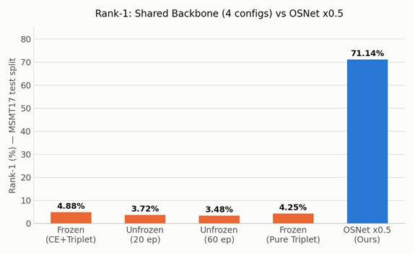
Figure 6.1 – Rank-1 accuracy on MSMT17: four shared-backbone training configurations vs. OSNet x0.5.
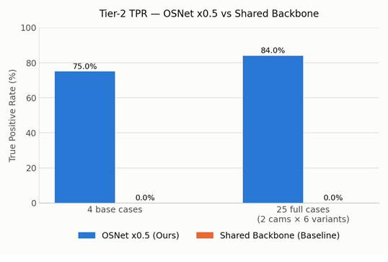
Figure 6.2 – Tier-2 True Positive Rate on real recorded data, both systems.
Remark. The gap does not narrow on any metric. Even the best shared-backbone configuration reached only 4.88% Rank-1, and all four of its training configurations failed completely at Tier-2 (0/25 real matching cases) — confirming that a backbone trained for pose classification discards the appearance detail Re-ID requires, regardless of how its Re-ID head is subsequently trained. OSNet x0.5 reached 84.0% TPR on the full 25-case set, and every remaining error traced back to a single camera view (CAM 2).

Identity Association
Metric | Geometry-only (paper, EPFL) | GNN-CCA full (paper, EPFL) | P2 Hungarian (Ours, n=840)
ARI | 43.49 | 84.76 | 85.45
AMI | 55.40 | 87.65 | 85.46
Homogeneity | 52.48 | 93.81 | 99.97
Completeness | 99.03 | 92.53 | 91.91
V-measure | 60.96 | 93.00 | 95.01
Table 6.3 — P2 (Hungarian, own real data) compared against literature-reported GNN-CCA results on EPFL.
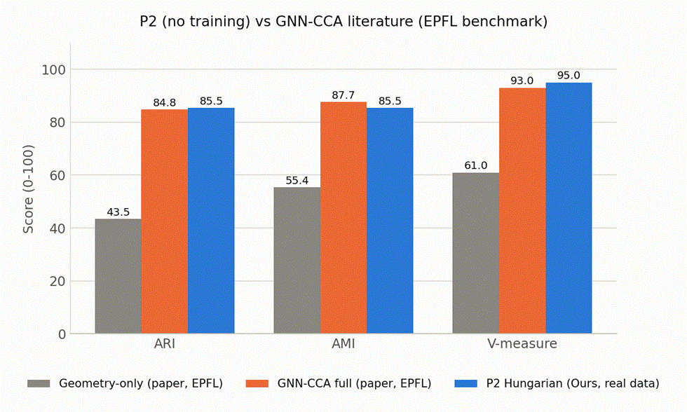
Figure 6.1 — P2 Hungarian (own real data) vs Geometry-only and GNN-CCA full (literature, EPFL).
Scene | Description | n | ARI (Hungarian) | ARI (Threshold+CC)
1 | Standing 1–1.5 m apart (normal) | 150 | 100.0 | 100.0
2 | Standing/sitting very close (most ambiguous) | 120 | 100.0 | 49.2
3 | One person occluded in one camera | 175 | 74.3 | 74.3
4 | One person falls, one stands nearby | 395 | 80.5 | 79.1
Table 6.4 — Per-scene ARI, P2 Data 3 (own data, n=840, original + 4 augmented variants).
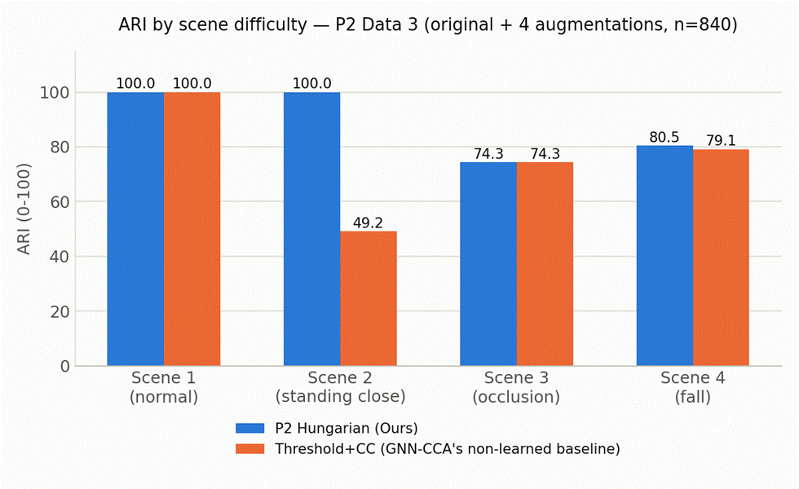
Figure 6.2 — ARI by scene difficulty, P2 Hungarian vs Threshold+CC.
Analysis. On the team's own two-camera, small-occupancy data, the training-free Hungarian method matches or slightly exceeds GNN-CCA's own literature numbers on EPFL (ARI 85.45 vs 84.76; V-measure 95.01 vs 93.00) — despite GNN-CCA clearly beating its own non-learned baseline at EPFL's scale (84.76 vs 43.49 ARI). This is not evidence that geometry generally beats learned graph matching; it reflects two specific factors: the deployment scale (1–2 people, 2 cameras) is small enough that most identity ambiguity a GNN resolves does not arise, and the choice of assignment algorithm matters more than whether it is learned — visible directly in Scene 2, where a naive distance threshold drops to 49.2% ARI while Hungarian's globally-optimal assignment holds 100% across every variant. Scene 3 (occlusion) is the one case where both methods perform identically worse (74.3%), since occlusion is a missing-detection problem no matching algorithm can fix.
Limitations. The comparison uses literature numbers (EPFL) against the team's own real data, not the same method on identical inputs. Ground truth for the team's own data is bootstrapped from Hungarian's own repeated pairing frequency, not independent labeling, and may carry a mild bias favoring Hungarian. The Jetson cost comparison for GNN-CCA is an informed estimate, not a direct benchmark.

Boundary Feature Fusion
Table 6.2 compares the group's fusion design against a re-implementation of Espinosa et al. (2019), evaluated on the same 36-case, scene-level test set (24 fall scenes / 12 ADL scenes).
Metric | Boundary Fusion (Ours) | Espinosa (Baseline)
Sensitivity (n=24 falls) | 100.0% (24/24) | 29.17% (7/24)
Specificity (n=12 ADL) | 41.7% (5/12) | 83.3% (10/12)
Accuracy (n=36) | 80.6% | 47.2%
FPS on Jetson Nano 4GB (model scope only) | 37.31 | not measured (CPU-based, not Jetson-targeted)
Table 6.2 – Boundary Feature Fusion: group design vs. Espinosa et al. (2019) baseline, scene level.
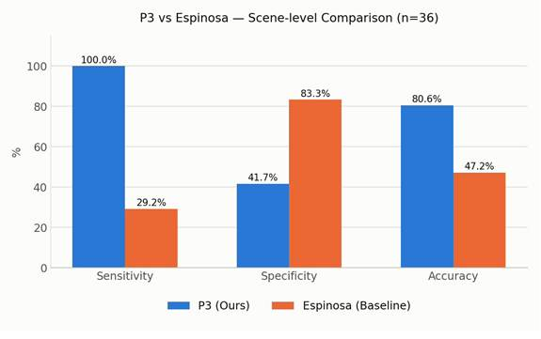
Figure 6.3 – Sensitivity, specificity, and accuracy, group design vs. Espinosa baseline, scene level (n=36).
Remark. The group's design does not miss a single fall in this test set, at the cost of a higher false-alarm rate than Espinosa's optical-flow baseline (58.3% of ADL scenes flagged, versus 16.7%). For a system whose target population is elderly people living alone, this is the intended trade-off — missing a real fall is materially worse than one extra alert — but the specificity gap is a genuine limitation, revisited in Section 6.6.

6.6 Discussion
Rather than analyzing each problem's failure modes in isolation, this section groups the observed errors by underlying cause, since two of the three problems share the same root issues.
Lighting and appearance differences between the two cameras are the most consistent source of error across the identity-related components. In Re-Identification, all four of the twenty-five Tier-2 test errors occurred on the same camera (CAM 2), where a person returning to view was scored close to a different gallery identity. Camera-conditional Normalization (CBN) was proposed specifically to reduce this camera-to-camera appearance bias, but its implementation status has not been confirmed at the time of writing, and it should not be presented as an adopted, working component until that is verified. The same underlying sensitivity to viewing and lighting conditions appears in the Espinosa baseline used for Boundary Feature Fusion, whose accuracy fell from 95.64% on its original paper's dataset, to 82.84% on the same-distribution MCFD test split, to 47.2% on the group's own recording conditions — direct evidence that appearance- and motion-based features degrade sharply once camera angle, lighting, and distance shift away from the training distribution.
People standing close together, or a person's body being physically split across two camera views, is the second recurring cause of error, and it primarily concerns Identity Association. Hungarian-assignment matching depends on the floor-projected footpoint falling within a distance threshold of the correct candidate in the other view; two people standing near one another narrow that margin and raise the risk of a false merge, an effect that has not yet been quantified on a larger multi-person test set (Section 6.5.2). A related effect appears in Boundary Feature Fusion: because the shared Pose Head was trained only on single-camera features and has never seen the fused, “mixed” feature vector at training time, its confidence on fused input is not guaranteed to be reliable. This is a likely contributor to why frame-level sensitivity for the group's own system is markedly lower than scene-level sensitivity (48.6% vs. 100%): the scene-level windowed decision rule absorbs individual frame-level misclassifications that occur during the visually ambiguous moment of falling.
The sensitivity/specificity trade-off itself is a deliberate design choice rather than an unexplained weakness: given the target use case — an elderly person living alone — missing a real fall is judged materially worse than one extra false alarm, so the system is tuned to favor sensitivity. The resulting 41.7% specificity is acknowledged here as a real limitation, not concealed, and an additional filtering rule at the decision layer (for example, requiring two consecutive positive windows before alerting) is proposed as future work rather than claimed as already implemented.

7. CONCLUSION AND FUTURE WORK
This thesis set out to validate three design decisions for multi-camera fall detection on constrained edge hardware, and the results in Chapter 6 provide evidence, not assumption, for each. For P1, empirical testing overturned the originally planned shared-backbone Re-ID design — it failed completely on real gallery matching — and confirmed an independent OSNet x0.5 model as the correct choice, at an acceptable additional inference cost on the Jetson Nano 4GB. For P2, a training-free Hungarian-based matching step was shown to be sufficient at the household deployment scale, reaching clustering scores comparable to a fully learned GNN baseline's own literature numbers, at negligible computational cost. For P3, the training-free, geometry-driven fusion mechanism achieved substantially higher fall-detection sensitivity than a representative learned early-fusion baseline, at the cost of lower specificity — a trade-off consistent with prioritizing not missing a real fall over avoiding a false alarm.
Future work includes: the ablation study isolating the specific contribution of multi-camera fusion under occlusion, still missing from the current results and needed to fully support the multi-camera claim in the thesis title; a secondary temporal filter to raise P3's scene-level specificity without reducing its current 100% sensitivity; re-tuning P1's gallery-matching threshold and buffer size against the OSNet x0.5 score distribution now measured, since its remaining errors cluster on one camera and may reflect a tuning issue rather than a fundamental limitation; and, if time permits, obtaining labeled data to run GNN-CCA directly on the team's own P2 data for a same-dataset comparison rather than the current cross-dataset one. Finally, Section 4.3 of this report should be revised to describe the Re-ID architecture actually deployed and evaluated in Chapter 6, rather than the shared-backbone design shown here to be non-functional.

REFERENCES
[1] N. Poudel et al., “Knowledge, attitude and practice on fall risk factors and prevention among rural older community-dwellers in Vietnam,” PMC, 2023. https://www.ncbi.nlm.nih.gov/pmc/articles/PMC10688746/
[2] M. E. N. Gomes, P. S. G. de-Mattos-Neto, C. Zanchettin, L. N. Matos, and B. S. Morais, “Fall Detection Based on Computer Vision: A Systematic Mapping Study,” IEEE Journal of Biomedical and Health Informatics, 2026 (Online ahead of print), doi: 10.1109/JBHI.2026.3686310.
[3] “Global, regional, and national burden of falls among older adults: findings from the Global Burden of Disease Study 2021 and Projections to 2040,” PMC, 2024–2025. https://pmc.ncbi.nlm.nih.gov/articles/PMC12511421/
[4] “Té ngã ở người cao tuổi: Cách xử trí và phòng chống,” YouMed, 2025. https://youmed.vn/tin-tuc/te-nga-o-nguoi-cao-tuoi-cach-xu-tri-va-phong-chong/
[5] T. I. Amosa, P. Sebastian, L. I. Izhar, O. Ibrahim, L. S. Ayinla, A. A. Bahashwan, A. Bala, and Y. A. Samaila, “Multi-camera multi-object tracking: A review of current trends and future advances,” Neurocomputing, vol. 552, Art. 126558, 2023.
[6] S. Yang, F. Ding, P. Li, and S. Hu, “Distributed multi-camera multi-target association for real-time tracking,” Scientific Reports, vol. 12, Art. 11052, 2022.
[7] S. Khalili, H. Mohammadzade, and M. M. Ahmadi, “Elderly Fall Detection Using CCTV Cameras under Partial Occlusion of the Subject's Body,” arXiv:2208.07291, 2022.
[8] R. Cucchiara, A. Prati, and R. Vezzani, “A multi-camera vision system for fall detection and alarm generation,” Expert Systems, vol. 24, no. 5, pp. 334–345, 2007.
[9] M. D. Solbach and J. K. Tsotsos, “Vision-Based Fallen Person Detection for the Elderly,” arXiv:1707.07608, 2017.
[10] O. Javed, Z. Rasheed, K. Shafique, and M. Shah, “Tracking Across Multiple Cameras With Disjoint Views,” in Proc. ICCV, 2003, pp. 952–957.
[11] A. Hermans, L. Beyer, and B. Leibe, “In Defense of the Triplet Loss for Person Re-Identification,” arXiv:1703.07737, 2017.
[12] W. Xiang, H. Yong, J. Huang, X.-S. Hua, and L. Zhang, “Second-order Camera-aware Color Transformation for Cross-domain Person Re-identification,” in Proc. ACCV, 2020.
[13] Z. Zhong, L. Zheng, Z. Zheng, S. Li, and Y. Yang, “Camera Style Adaptation for Person Re-identification,” in Proc. CVPR, 2018.
[14] X. Pan, P. Luo, J. Shi, and X. Tang, “Two at Once: Enhancing Learning and Generalization Capacities via IBN-Net,” in Proc. ECCV, 2018, pp. 464–479.
[15] Z. Zhuang, L. Wei, L. Xie, T. Zhang, H. Zhang, H. Wu, H. Ai, and Q. Tian, “Rethinking the Distribution Gap of Person Re-identification with Camera-Based Batch Normalization,” in Proc. ECCV, 2020, pp. 140–157.
[16] Z. Wang, L. Zheng, Y. Liu, and S. Wang, “Towards Real-Time Multi-Object Tracking,” in Proc. ECCV, 2020, pp. 107–122.
[17] Y. Zhang, C. Wang, X. Wang, W. Zeng, and W. Liu, “FairMOT: On the Fairness of Detection and Re-Identification in Multiple Object Tracking,” IJCV, vol. 129, no. 11, pp. 3069–3087, 2021.
[18] K. Zhou, Y. Yang, A. Cavallaro, and T. Xiang, “Omni-Scale Feature Learning for Person Re-Identification,” in Proc. ICCV, 2019, pp. 3701–3711.
[19] F. Fleuret, J. Berclaz, R. Lengagne, and P. Fua, “Multicamera People Tracking with a Probabilistic Occupancy Map,” IEEE Trans. Pattern Anal. Mach. Intell., vol. 30, no. 2, pp. 267–282, Feb. 2008.
[20] J. Berclaz, F. Fleuret, E. Turetken, and P. Fua, “Multiple Object Tracking Using K-Shortest Paths Optimization,” IEEE Trans. Pattern Anal. Mach. Intell., vol. 33, no. 9, pp. 1806–1819, Sep. 2011.
[21] T. Teepe, P. Wolters, J. Gilg, F. Herzog, and G. Rigoll, “EarlyBird: Early-Fusion for Multi-View Tracking in the Bird's Eye View,” in Proc. IEEE/CVF Winter Conf. Applications of Computer Vision (WACV) Workshops, 2024, pp. 102–111.
[22] P. Zhang, S. Wang, W. Zhang, W. Lei, X. Zhao, and Q. Jing, “Cross-Camera Tracking Model and Method Based on Multi-Feature Fusion,” Symmetry, vol. 15, no. 12, p. 2145, 2023.
[23] S. Ezatzadeh, M. R. Keyvanpour, and A. Khadem, “A Human Fall Detection Framework Based on Multi-Camera Fusion,” J. Exp. Theor. Artif. Intell., vol. 34, no. 6, pp. 905–924, 2021.
[24] H. Ma, L. Chen, D. Kong, Z. Wang, X. Liu, H. Tang, X. Yan, Y. Xie, S.-Y. Lin, and X. Xie, “TransFusion: Cross-View Fusion with Transformer for 3D Human Pose Estimation,” in Proc. Brit. Mach. Vis. Conf. (BMVC), 2021.
[25] H. Qiu, C. Wang, J. Wang, N. Wang, and W. Zeng, “Cross View Fusion for 3D Human Pose Estimation,” in Proc. IEEE/CVF Int. Conf. Comput. Vis. (ICCV), 2019, pp. 4342–4351.
[26] C.-H. Yen, “Person re-identification and tracking for multiple embedded edge cameras,” M.S. thesis, Dept. of Electrical Engineering, National Taipei University of Technology, 2022.
[27] L. Teepe, A. Herzog, and M. Hofmann, “Deep multi-camera 3D multi-object tracking on edge devices,” IEEE Transactions on Intelligent Vehicles, 2024.
[28] E. Luna, J. C. SanMiguel, J. M. Martínez, and P. Carballeira, “Graph Neural Networks for Cross-Camera Data Association,” IEEE Transactions on Circuits and Systems for Video Technology, vol. 33, no. 2, pp. 589–601, 2022.
[29] H. W. Kuhn, “The Hungarian method for the assignment problem,” Naval Research Logistics Quarterly, vol. 2, no. 1‑2, pp. 83–97, 1955.

